
A
Report on
BuildSphere – Construction Project Management System
under
Mini Project (NSP) 253CI7-50
Session 2026–27
Submitted by:  Rohit Sharma (PIET25CI051)  Shreya Goswami (PIET25CI057)  Somya Vijay (PIET25CI058) | Submitted to:  Ms. Samiksha Agarwal  Assistant Professor  Department of Internet of Things

Department of Internet of Things
Poornima Institute of Engineering & Technology
ISI-2, RIICO Institutional Area, Sitapura, Jaipur – 302022
Rajasthan, India
http://www.poornima.org

Software Requirements Specification (SRS)
BuildSphere-Construction Project Management System. IEEE Std 830-1998 Compliant

Field Details
Project Name BuildSphere - Construction Project Management System

Version 1.0
Technology Java Swing, Core Java(OOP), JDBC, MySQL Server
Package Construction_Management_System Date September 2026
Status Prototype / Under Development
2.Executive Abstract
BuildSphere is an integrated Java-based Construction Project Management System engineered to digitize, streamline, and centralize on-site civil engineering and site-supervision operations. In traditional job-site environments, core operational activities—encompassing daily labor rosters, raw material requisitions, stock balances, heavy machinery utilization, daily progress tracking, and site safety audits—are managed via fragmented paper registers, physical logbooks, or disconnected spreadsheets. This decentralized operational paradigm frequently results in severe data discrepancies, inventory leakage, calculation mistakes, and delayed executive reporting.
The primary objective of BuildSphere is to deliver a robust, secure, and transactional desktop enterprise system built on a structured three-tier architecture. The presentation layer utilizes Java Swing to offer an intuitive user experience; the business logic tier is implemented in Core Java strictly adhering to Object-Oriented Design (OOD) principles; and the persistence tier leverages Java Database Connectivity (JDBC) with a normalized MySQL relational database. Role-based access control (RBAC) ensures strict authorization boundaries for System Administrators, Project Managers, Site Engineers, and Storekeepers.
The current scope encompasses complete modular implementations for workforce monitoring, inventory life-cycles, daily progress reporting (DPR), equipment deployment, and occupational safety incident tracking. Out-of-scope capabilities such as cloud microservices, AI-driven delay forecasting, and IoT biometric hardware are slated for future iterations. BuildSphere serves as a comprehensive demonstration of core Software Engineering lifecycle standards, covering IEEE-compliant requirement specifications, UML modeling, relational schema normalization, Agile sprints, and systematic verification.

3.Table of Contents
1.Cover Page & Institutional Metadata
2.Executive Abstract
3.Table of Contents
4.Introduction & Background Motivation
5.Problem Statement & Current Industry Challenges
6.Project Objectives & Scope Boundaries
7.Literature Survey & Existing System Analysis
8.Proposed System Architecture & Workflow
9.Software Requirements Specification (SRS)
10.Multi-Dimensional Feasibility Study
11.System Architecture & Module Design
12.UML & Object-Oriented Design Models
13.Java Swing GUI Prototype Specifications
14.GUI Navigation & Role-Based Workflows
15.MySQL Database Design & Schema Specifications
16.Database Normalization & Data Integrity
17.Database Implementation: DDL & DML Scripts
18.Technology Stack & Development Environment
19.Project Plan, Sprint Tracking & Current Status
20.Expected Technical & Academic Outcomes
21.Conclusion & Future Research Roadmap
22.References & Regulatory Standards


4 Introduction & Background Motivation
4.1 Industry Background

Civil infrastructure and commercial construction projects operate within dynamic, high-stakes environments characterized by substantial capital investment, tight delivery schedules, diverse skilled and unskilled workforces, and heavy logistical throughput. On any typical site, multiple operational streams run concurrently: skilled tradesmen must be mobilized; raw building consumables (cement, structural steel, aggregate, ready-mix concrete) must be inspected, stored, and issued; heavy machinery must be maintained; and daily progress logs must be validated against engineering milestones.

Despite the rapid digitization of architectural design (CAD/BIM), field operations on small-to-medium construction sites remain largely reliant on legacy analog practices. Physical journals, hand-written slips, and uncoordinated local spreadsheets remain the norm, resulting in fragmented data silos, untracked shrinkage, and inaccurate financial forecasting.

4.2 Project Motivation

BuildSphere was initiated to bridge the operational gap between field engineering teams and managerial oversight. By providing an integrated, localized desktop solution, BuildSphere automates transactional record-keeping, establishes accountability across role hierarchies, enforces audit trails, and consolidates diverse site records into actionable operational dashboards.

The system addresses ten primary operational areas:

. Authentication & Security: Multi-tiered RBAC safeguarding administrative functions.

. Project Portfolio Management: Centralized timeline, site location, and status monitoring.

. Workforce Management: Comprehensive tradesperson registers, rate cards, and profile archives.

. Attendance & Wage Tracking: Digital check-in/out records with automated man-hour accounting.

. Consumable Material Master: Standardized categorization, units of measurement (UoM), and minimum buffer thresholds.

. Stock Inward & Inventory Control: Verification of vendor dispatches, deliveries, and stock on hand.

. Material Issue Management: Traceable internal allocation of stock to specific sub-contractors or building blocks.

. Daily Progress Reporting (DPR): Systematic logging of work completed, manpower utilized, and impediments encountered.

. Heavy Equipment Tracking: Machine deployment, operator assignment, and maintenance schedules.

. HSE / Safety Incident Auditing: Recording workplace hazards, severity classifications, and corrective action lifecycles.

4.3 Application of Software Engineering Principles

The project is grounded in established Software Engineering paradigms. Rather than an ad-hoc programming exercise, BuildSphere systematically applies:

. Requirement Analysis & Modeling: Adhering to IEEE Std 830-1998 guidelines to eliminate scope ambiguity.

. Object-Oriented Analysis and Design (OOAD): Designing loosely coupled, highly cohesive domain objects that mirror real-world construction entities.

. Architectural Separation of Concerns: Isolating presentation widgets from domain business logic and database persistence (DAO pattern).

. Relational Database Normalization: Decomposing tables to Third Normal Form (3NF) to eliminate anomalies.

. Agile Iterative Delivery: Decomposing development into sprint-based increments with continuous quality assurance.

5.Problem Statement
5.1 Inherent Deficiencies in Conventional Systems
Problem Dimension | Conventional / Manual Practice | Direct Operational Impact
Record Durability | Physical paper logbooks, paper attendance muster rolls. | Vulnerable to physical deterioration, environmental damage, and loss.
Inventory Shrinkage | Unlinked dispatch challans and informal issue slips. | Unaccounted material loss, untracked pilferage, unexpected stock-outs.
Labor Accounting | Manual muster rolls marked by sub-contractors. | Ghost labor entries, inaccurate overtime calculations, wage disputes.
Reporting Latency | End-of-month manual compilation into spreadsheets. | Executive delay in detecting cost overruns and structural schedule slippage.
Safety Compliance | Verbal hazard reprimands without documented tracking. | Repeated workplace accidents, statutory non-compliance with BOCW Act.

5.2 Formal Problem Definition
There exists an acute requirement for an accessible, zero-licensing-cost, standalone software system that enables site supervisors and project managers to systematically record, cross-validate, and audit construction transactions in real time. BuildSphere directly solves this operational bottleneck by offering an integrated Java-MySQL transactional platform capable of executing deterministic data persistence, rigorous referential constraints, and immediate reporting.

6.Objectives & Scope Boundaries
  - Primary Objectives
- Centralized Data Repository: Establish a unified relational schema eliminating redundant records across projects.
- Worker & Labor Lifecycle Management: Maintain verified records of trades, contact profiles, daily wages, and accurate check-in/out times.
- Traceable Material Movement: Track stock inward receipts against purchase orders and trace outward issues to specific activities.
- Asset & Fleet Monitoring: Maintain an active inventory of site machinery, tracking maintenance intervals, current condition, and assigned operators.
- Digital Daily Progress Reporting: Provide a standardized interface for site engineers to submit daily work summaries, weather impediments, and resource metrics.
- HSE Compliance Tracking: Document safety breaches, assign remediation responsibilities, and monitor compliance status until closure
- Role-Enforced Application Security: Restrict database access via role-based credentials.

Boundary Analysis: In-Scope vs Out-of-Scope
In-Scope(Current Mid-Term Version) | Out-of-Scope(Future Enhancement)
Java Swing Graphical Desktop Application | Android / iOS Native Mobile Applications
Local/Intranet MySQL Relational Database Server | Distributed Cloud Native Infrastructure (AWS / Azure)
Manual UI-driven Check-in / Check-out Attendance | Biometric Fingerprint, Facial Recognition & Geofencing
Rule-based Inventory Threshold Alerts | AI-driven Machine Learning Schedule & Cost Prediction
Tabular Form Reporting & In-memory Search Filters | BIM(Building Information Modeling) 3D Model Viewers
7.Literature Survey & Existing System Analysis
A comparative analysis of existing market platforms reveals a significant gap. Commercial tier-1 enterprise platforms (e.g., Procore, Autodesk Construction Cloud, Oracle Primavera P6) are feature-rich but prohibitively expensive, require continuous broadband internet access (often unavailable at remote greenfield sites), and demand specialized training. Conversely, basic spreadsheet software lacks referential integrity, allows accidental cell overwrites, provides zero concurrent role security, and fails to maintain immutable audit trails.
Comparative Parameter | Manual Paper Logbooks | Microsoft Excel Sheets | Enterprise ERP (Procore) | BuildSphere System
Licensing & Cost | Negligible(Paper) | Office 365 Licence | Extremely Expensive | Free/Open Source
Offline Capability | 100% Offline | Offline Supported | Cloud Reliant | Full Offline/Local DB
Data Integrity | Zero Integrity | Weak(Formulas break) | High | High(RDBMS Constraints)
Role-Based Security | None | Basic Password | Advanced | Multi-tier RBAC

8. Software Requirements Specification(SRS)
8.1 Detailed Functional Requirements
Req ID | Module Name | Detailed Functional Description
FR-01 | Authentication | Authenticate user credentials against hashed database records with session timeout enforcement.
FR-02 | Access Control | Authorize navigation access based on assigned roles (Admin, Manager, Site Engineer, Storekeeper).
FR-03 | Project Master | Provision CRUD actions on construction projects, enforcing date validations and audit timestamps.
FR-04 | Worker Registry | Enroll workers with unique alphanumeric codes, designated trade skills, daily wage baselines, and emergency contact details.
FR-05 | Attendance Logging | Record daily shift attendance per project, logging check-in/out timestamps and automatic status flags (Present, Half-Day, Absent).
FR-06 | Material Master | Catalog site materials with standardized Units of Measure (Bags, Tons, Cu.M) and minimum safety stock parameters.
FR-07 | Stock Control | Process inward inventory additions, update ledger levels, and log reference delivery challan numbers.
FR-08 | Material issue | Deduct inventory for field allocations, validate available stock balances, and assign material issues to specific subcontractors.
FR-09 | Daily Progress Report (DPR) | Document daily work completed, manpower count deployed, equipment hours, and weather disruptions.
FR-10 | Equipment Tracking | Track machinery allocation, status transitions (Available, In Use, Under Maintenance), and preventive servicing dates.
FR-11 | Safety Compilance | Log safety non-conformances, assign severity ratings (Low, Medium, Critical), and record mandatory corrective action plans.
FR-12 | reporting & Query | Provide real-time tabular search, filtering across worker records, date-range muster reports, and inventory consumption summaries.

8.2 Non-Functional Requirements (NFR)
Performance: Database search and transactional updates must execute with a response latency under 500 milliseconds for standard operational queries.
Usability: Graphical screens must adhere to standard desktop UX conventions, utilizing clear form field labels, accessible hotkeys, and validation error highlights.
Security: Plain-text passwords must be prevented. Database connections must use parameterized prepared statements to eliminate SQL Injection (CWE-89).
Reliability & ACID Compliance: All inventory issue transactions must be wrapped in atomic database transactions to prevent partial updates.
Maintainability: Code must strictly follow Java OOP conventions, separating Controller logic from Data Access Objects (DAO).
Portability: The compiled bytecode (`.jar`) must execute consistently across cross-platform environments running JRE 17 or higher.
8.3 Technical Environment Specifications
Category | Minimum Requirements | Recommended Specifications
Processor | Dual Core 2.0 GHz x86-64 | Quad Core Intel Core i5 / AMD Ryzen 5 or higher
System Memory (RAM) | 4 GB DDR4 | 8 GB / 16 GB DDR4
Secondary Storage | 10 GB Free Storage Space | SSD with 25 GB+ Free Storage Space
Java Environment | Java Development Kit (JDK) 17 LTS | Java Development Kit (JDK) 21 LTS
Relational Database | MySQL Community Server 8.0 | MySQL Community Server 8.0+ with Workbench

9.Multi-Dimensional Feasibility Study
9.1 Technical Feasibility
The project leverages proven technologies: Java Swing, Core Java, JDBC, and MySQL. The engineering team possesses strong foundational knowledge in object-oriented programming, relational database modeling, and GUI event handling. Standard development environments (IntelliJ IDEA, Eclipse, MySQL Workbench) provide robust debugging, schema administration, and profiling capabilities. The project is technically sound and achievable.
9.2 Operational Feasibility
The desktop application uses an intuitive interface designed for site engineers, store managers, and safety auditors who possess basic computer literacy. Replacing physical paper registers with clear forms, pick-lists, and tabular overviews eliminates the need for manual calculations, directly reducing human error.
9.3 Economic Feasibility
BuildSphere is built entirely on open-source, community-licensed tools, incurring zero direct software procurement expenditures. Development makes use of free developer toolkits (OpenJDK, MySQL Community Edition, Git, StarUML community edition).

9.4 Schedule Feasibility
Development is mapped across an 8-Sprint Agile roadmap aligning directly with academic milestones, ensuring timely deliverables from requirement drafting to final testing.

10.System Architecture & Detailed Module Design
10.1 Three-Tier Architecture
BuildSphere implements a classic, robust Three-Tier Client-Server Architecture that enforces strict separation of concerns across functional layers:
. Presentation Tier (UI Layer): Composed of Java Swing classes (JFrame, JPanel, JTable, JButton) responsible for rendering operational forms, capturing user input, and displaying tabular data.
. Business Logic Tier (Application Service Layer): Composed of Plain Old Java Objects (POJOs), entity models, controller classes, and validation services. Handles input sanitation, business constraints, and role authorizations.
. Data Access Tier (Persistence Layer): Implemented using the Data Access Object (DAO) pattern communicating via Java Database Connectivity (JDBC) over TCP/IP to the MySQL Relational Engine.
10.2 Module Breakdown & Functional Responsibilities
Module Name | Core Operational Scope | Key Attributes
- Login & Security | User credential authentication, role assignment, and session initialization. | user_id, username, password_hash, role, full_name
- Project Management | Site project initialization, timeline scheduling, and project-level tracking. | project_id, project_name, location, start_date, end_date, status
- Worker Management | Labor database, skill categorization (Mason, Carpenter, Electrician, Helper) | worker_id, worker_code, name, phone, trade, daily_wage, status
- Attendence Register | Shift-level labor muster recording, check-in, check-out, and payroll metrics. | attendance_id, worker_id, project_id, attendance_date, check_in, check_out, status
- Material Master | Standard consumable cataloging, inventory unit definitions, and buffer limits. | material_id, project_id, material_name, unit, min_stock_level
- Stock Inward | Receipt of vendor deliveries, stock balance increments, challan logs. | stock_id, material_id, transaction_type, quantity, challan_no, date
- Material Issue | Deductions from stock, allocation tracking to specific site work packages. | issue_id, material_id, issued_to, quantity, issue_date, purpose
- Daily Progress Report (DPR) | End-of-day site reports, completed tasks, delays, and manpower counts. | dpr_id, project_id, report_date, work_done, manpower_used, issues
- Equipment Tracking | Plant and machinery logs, operational status, servicing schedules. | equipment_id, name, type, operator_name, maintenance_date, status
- Safety Violation | HSE hazard logs, severity levels, corrective action mandates, resolution flags. | violation_id, project_id, reported_by, severity, description, status

11.UML & Object-Oriented Design Models

System architecture and relational associations were formally specified in StarUML adhering to standard OMG UML specifications.

11.1 Entity-Relationship (ER) Model
The database schema consists of ten primary relational entities interconnected through enforced foreign keys:
. USERS (1) to PROJECT (N): A project administrator can create and supervise multiple construction sites.
. PROJECT (1) to WORKER (N): Multiple workers are assigned to a construction project.
. WORKER (1) to ATTENDANCE (N): Each worker accumulates historical daily attendance entries.
. PROJECT (1) to MATERIAL (N): Material catalog records are maintained per project.
. MATERIAL (1) to MATERIAL_STOCK (N) & MATERIAL_ISSUE (N): Every material item maintains a transactional history of inward deliveries and outward site allocations.
. PROJECT (1) to DPR (N), EQUIPMENT (N), and SAFETY_VIOLATION (N): Daily progress, heavy machinery, and safety audit incidents are linked directly to their parent project.

11.2 Data Flow Diagram (DFD)
DFD Level 0 (Context Level): Models the entire application as a single centralized process communicating with six external entities: Admin, Project Manager, Site Engineer, Storekeeper, Worker, and Safety Officer. Transactional records are persisted directly into the MySQL database.

DFD Level 1 (Decomposition): Decomposes the operational environment into eight distinct processes: 1.0 Authentication, 2.0 Project Lifecycle Administration, 3.0 Labor Muster Operations, 4.0 Consumables & Stock Warehousing, 5.0 Equipment & Plant Deployment, 6.0 DPR Generation, 7.0 Safety Hazard Auditing, and 8.0 Management Analytics.

11.3 Dynamic Behavioral Models (Sequence & Activity Diagram)
Sequence Flow (Material Issue): Storekeeper logs in → requests Material Issue Screen → selects Material ID → inputs requisition quantity → system validates entered quantity against available stock balance → if valid, begins database transaction → inserts record into material_issue → updates balance → commits transaction → returns confirmation to UI.
Activity Flow (Worker Attendance): Site Supervisor opens Attendance Module → selects target Project & Worker ID → system auto-populates system timestamp → supervisor confirms status (Present/Half-day/Absent) → system validates duplicate entries for the current date → if unique, saves record to attendance table → updates live muster roll table.

12.MySQL Database Design & Data Dictionary
The database schema, designated as buildsphere_db, is structured to ensure Third Normal Form (3NF) compliance and referential integrity:

12.1 Data Schema Dictionary
Table Name | Primary keys | Secondary keys | Key Business Constraints
Users | user_id | None | username UNIQUE, role IN ('Admin','Manager','Engineer','Storekeeper')
project | project_id | created_by → users(user_id) | end_date ≥ start_date, project_name NOT NULL
worker | worker_id | user_id → users(user_id) | worker_code UNIQUE, daily_wage > 0
attendance | attendance_id | worker_id, project_id | UNIQUE(worker_id, attendance_date)
material | material_id | project_id → project(project_id) | min_stock_level ≥ 0
material_stock | stock_id | material_id, project_id | quantity > 0, transaction_type = 'INWARD'
material_issue | issue_id | material_id, project_id, issued_by | quantity > 0, issued_to NOT NULL
dpr | dpr_id | project_id, prepared_by | manpower_used ≥ 0
equipment | equipment_id | project_id → project(project_id) | status IN ('Available','In Use','Maintenance','Inactive')
safety_violation | violation_id | project_id, reported_by | severity IN ('Low','Medium','High','Critical')

13. Database Normalization & Integrity Enforcement

13.1 Normalization Process
. First Normal Form (1NF): All attributes contain atomic values. Multi-valued records (e.g., listing multiple workers or materials in a single comma-separated string) are decomposed into distinct rows with unique keys.
. Second Normal Form (2NF): All non-key attributes are fully functionally dependent on the entire primary key, eliminating partial dependencies.
. Third Normal Form (3NF): Transitive dependencies are removed across all tables. Non-key attributes rely exclusively on the primary key (e.g., worker daily rates are maintained in the `worker` table rather than duplicated in the `attendance` table).

14. Database Implementation: DDL & DML Scripts
Below are the core Data Definition and Data Manipulation scripts implemented in MySQL Server 8.0:
-- 1. Database Initialization
CREATE DATABASE IF NOT EXISTS buildsphere_db;
USE buildsphere_db;
-- 2. Users Table Schema
CREATE TABLE IF NOT EXISTS users (
user_id INT PRIMARY KEY AUTO_INCREMENT,
username VARCHAR(50) UNIQUE NOT NULL,
password VARCHAR(255) NOT NULL,
role VARCHAR(30) NOT NULL,
full_name VARCHAR(100) NOT NULL,
created_at TIMESTAMP DEFAULT CURRENT_TIMESTAMP
);
-- 3. Projects Table Schema
CREATE TABLE IF NOT EXISTS project (
project_id INT PRIMARY KEY AUTO_INCREMENT,
project_name VARCHAR(100) NOT NULL,
location VARCHAR(150) NOT NULL,
start_date DATE NOT NULL,
end_date DATE NOT NULL,
status VARCHAR(30) DEFAULT 'Active',
created_by INT,
created_at TIMESTAMP DEFAULT CURRENT_TIMESTAMP,
FOREIGN KEY (created_by) REFERENCES users(user_id) ON DELETE SET NULL
);
-- 4. Worker Master Table
CREATE TABLE IF NOT EXISTS worker (
worker_id INT PRIMARY KEY AUTO_INCREMENT,
user_id INT,
worker_code VARCHAR(30) UNIQUE NOT NULL,
name VARCHAR(100) NOT NULL,
phone VARCHAR(20),
address VARCHAR(255),
trade VARCHAR(50) NOT NULL,
daily_wage DECIMAL(10,2) NOT NULL,
status VARCHAR(20) DEFAULT 'Active',
created_at TIMESTAMP DEFAULT CURRENT_TIMESTAMP,
FOREIGN KEY (user_id) REFERENCES users(user_id) ON DELETE SET NULL
);
-- 5. Attendance Records Table
CREATE TABLE IF NOT EXISTS attendance (
attendance_id INT PRIMARY KEY AUTO_INCREMENT,
worker_id INT NOT NULL,
project_id INT NOT NULL,
attendance_date DATE NOT NULL,
check_in_time TIME,
check_out_time TIME,
status VARCHAR(20) NOT NULL,
remarks VARCHAR(255),
FOREIGN KEY (worker_id) REFERENCES worker(worker_id) ON DELETE CASCADE,
FOREIGN KEY (project_id) REFERENCES project(project_id) ON DELETE CASCADE,
UNIQUE KEY unique_daily_attendance (worker_id, attendance_date)
);
-- 6. Material Master Table
CREATE TABLE IF NOT EXISTS material (
material_id INT PRIMARY KEY AUTO_INCREMENT,
project_id INT NOT NULL,
material_name VARCHAR(100) NOT NULL,
unit VARCHAR(20) NOT NULL,
min_stock_level DECIMAL(10,2) DEFAULT 0.00,
created_at TIMESTAMP DEFAULT CURRENT_TIMESTAMP,
FOREIGN KEY (project_id) REFERENCES project(project_id) ON DELETE CASCADE
);
-- 7. Material Inward Stock Table
CREATE TABLE IF NOT EXISTS material_stock (
stock_id INT PRIMARY KEY AUTO_INCREMENT,
material_id INT NOT NULL,
project_id INT NOT NULL,
transaction_type VARCHAR(20) DEFAULT 'INWARD',
quantity DECIMAL(10,2) NOT NULL,
transaction_date DATE NOT NULL,
reference_no VARCHAR(50),
remarks VARCHAR(255),
FOREIGN KEY (material_id) REFERENCES material(material_id) ON DELETE CASCADE,
FOREIGN KEY (project_id) REFERENCES project(project_id) ON DELETE CASCADE
);
-- 8. Material Issue Table
CREATE TABLE IF NOT EXISTS material_issue (
issue_id INT PRIMARY KEY AUTO_INCREMENT,
material_id INT NOT NULL,
project_id INT NOT NULL,
issued_to VARCHAR(100) NOT NULL,
quantity DECIMAL(10,2) NOT NULL,
issue_date DATE NOT NULL,
purpose VARCHAR(255),
issued_by INT,
FOREIGN KEY (material_id) REFERENCES material(material_id) ON DELETE CASCADE,
FOREIGN KEY (project_id) REFERENCES project(project_id) ON DELETE CASCADE,
FOREIGN KEY (issued_by) REFERENCES users(user_id) ON DELETE SET NULL
);
-- 9. Daily Progress Report Table
CREATE TABLE IF NOT EXISTS dpr (
dpr_id INT PRIMARY KEY AUTO_INCREMENT,
project_id INT NOT NULL,
report_date DATE NOT NULL,
work_done TEXT NOT NULL,
manpower_used INT NOT NULL,
material_used TEXT,
issues TEXT,
remarks VARCHAR(255),
prepared_by INT,
created_at TIMESTAMP DEFAULT CURRENT_TIMESTAMP,
FOREIGN KEY (project_id) REFERENCES project(project_id) ON DELETE CASCADE,
FOREIGN KEY (prepared_by) REFERENCES users(user_id) ON DELETE SET NULL
);
-- 10. Plant & Equipment Tracking Table
CREATE TABLE IF NOT EXISTS equipment (
equipment_id INT PRIMARY KEY AUTO_INCREMENT,
project_id INT NOT NULL,
equipment_name VARCHAR(100) NOT NULL,
equipment_type VARCHAR(50),
model VARCHAR(50),
assigned_location VARCHAR(100),
operator_name VARCHAR(100),
purchase_date DATE,
maintenance_date DATE,
status VARCHAR(30) DEFAULT 'Available',
FOREIGN KEY (project_id) REFERENCES project(project_id) ON DELETE CASCADE
);
-- 11. Safety Non-Conformance Records Table
CREATE TABLE IF NOT EXISTS safety_violation (
violation_id INT PRIMARY KEY AUTO_INCREMENT,
project_id INT NOT NULL,
reported_by INT,
violation_date DATE NOT NULL,
category VARCHAR(50) NOT NULL,
severity VARCHAR(20) NOT NULL,
description TEXT NOT NULL,
corrective_action TEXT,
status VARCHAR(20) DEFAULT 'Open',
FOREIGN KEY (project_id) REFERENCES project(project_id) ON DELETE CASCADE,
FOREIGN KEY (reported_by) REFERENCES users(user_id) ON DELETE SET NULL
);
- Technology Stack & Implementation Framework
Technology | Role in BuildSphere | Engineering Justification
Java (JDK 17 LTS) | Core Language & Business Logic | Cross-platform capability, strict static type safety, and comprehensive OOP paradigms.
Java Swing | Presentation GUI Framework | Built-in desktop GUI framework requiring no external dependencies, offering complete UI layout controls.
JDBC API | Data Access Middleware | Provides reliable database connectivity and allows fine-grained transactional commit/rollback control.
MySQL Server 8.0 | Relational Persistence Engine | High-performance transactional engine supporting ACID properties, foreign keys, and indexes.
Git & GitHub | Distributed Version Control | Enables branch-based feature development, pull request code reviews, and commit audit trails.
JUnit 5 & Selenium | Automated Quality Assurance | Provides unit testing for business models and UI interaction automation.

16. Project Plan, Agile Sprints & Progress
The development of BuildSphere is managed via an 8-Sprint Agile delivery model:
Sprint | Planned Objectives | Key Deliverables | Status
Sprint 1 | Requirement Analysis | Stakeholder interviews, problem formulation, and IEEE SRS creation. | Completed
Sprint 2 | System Design & Modeling | StarUML diagrams (ER, DFD 0/1, Use Case, Class) and normalized schema. | Completed
Sprint 3 | Core Auth & Master Modules | Login window, RBAC session handling, Project and Worker CRUD panels. | In Progress
Sprint 4 | Muster & Warehouse Modules | Attendance logging, Material Master, Inward Stock, and Material Issue logic. | Scheduled
Sprint 5 | Site Operations & Safety | Equipment lifecycle tracking, Daily Progress Report forms, and Safety hazard audits. | Scheduled
Sprint 6 | Reporting & System Integration | Executive dashboard, dynamic search filters, and tabular export features. | Scheduled
Sprint 7 | Testing & Verification | JUnit 5 unit test execution, boundary validation, and bug remediation. | Scheduled
Sprint 8 | Documentation & Final Defense | Executable `.jar` packaging, user manual preparation, and project defense. | Scheduled

17. Expected Academic & Industrial Outcomes
. Functional Standalone Application: Delivery of a stable, production-ready desktop tool capable of running offline on site computers.
. Operational Accuracy: Drastic reduction in payroll discrepancies and inventory shrinkage through automated data cross-referencing.
. Standardized Documentation: Full alignment with IEEE Std 830-1998 standards, demonstrating competence in Software Engineering lifecycle workflows.
. Demonstrated Technical Competencies: Practical implementation of Java Swing GUI programming, JDBC connection pooling, 3NF schema design, and modular software testing.

18. Conclusion & Future Roadmap

18.1 Future Scope & Extension Capabilities
. IoT Hardware Integration: Direct connection with biometric fingerprint scanners and RFID turnstiles for automated labor check-ins.
. Predictive Analytics: Implementation of machine learning models to forecast project delays and estimate cost overruns based on historical DPR and weather trends.
. Cloud & Mobile Synchronization: Extending the system with a Spring Boot RESTful API and mobile field clients (Flutter/Android) to enable real-time field data sync.
. Computer Vision & Drone Audits: Processing aerial site photography to cross-verify DPR progress against physical structural milestones.

19. References & Regulatory Standards
- IEEE Computer Society, IEEE Std 830-1998: Recommended Practice for Software Requirements Specifications, IEEE, 1998.
- Ian Sommerville, Software Engineering, 10th Edition, Pearson Education, 2015.
- Roger S. Pressman and Bruce R. Maxim, Software Engineering: A Practitioner's Approach, 9th Edition, McGraw-Hill Education, 2020.
- Herbert Schildt, Java: The Complete Reference, 12th Edition, Oracle Press / McGraw-Hill, 2021.
- MySQL AB, MySQL 8.0 Reference Manual, Oracle Corporation, 2024.
- Bureau of Indian Standards, National Building Code of India (NBC 2016), Volume 1 & 2, New Delhi, India.
- Ministry of Labour and Employment, Building and Other Construction Workers (Regulation of Employment and Conditions of Service) Act, 1996, Government of India.
- Bureau of Indian Standards, IS 456:2000 - Plain and Reinforced Concrete - Code of Practice, Fourth Revision, BIS, New Delhi.

CERTIFICATE
This is to certify that the project entitled “BuildSphere – Construction Project Management System” has been developed and documented by the students of the Department of Internet of Things as a Mini Project (NSP 253CI7-50) during the academic session 2026–27.
The work presented in this report demonstrates the application of software engineering principles, Java programming, Java Swing, JDBC connectivity, MySQL database design, object-oriented analysis and design, and systematic software testing.
Particular | Details
Project | BuildSphere – Construction Project Management System
Course | Mini Project (NSP 253CI7-50)
Department | Department of Internet of Things
Session | 2026–27
Supervisor | Samiksha Agarwal, Assistant Professor

Supervisor Signature: ____________________ Date: ____________________
Head of Department Signature: ________________ Date: ____________________

DECLARATION
We hereby declare that the project report entitled “BuildSphere – Construction Project Management System” is our academic work prepared for the Mini Project (NSP 253CI7-50).
Team Members:
• Rohit Sharma (PIET25CI051)
• Shreya Goswami (PIET25CI057)
• Somya Vijay (PIET25CI058)
Signatures: ____________________ ____________________ ____________________

ACKNOWLEDGEMENT
We express our sincere gratitude to our project guide, Ms. Samiksha Agarwal, Assistant Professor, Department of Internet of Things, for her guidance, suggestions, and continuous academic support throughout the development and documentation of BuildSphere.
We are also thankful to the Department of Internet of Things and the institute for providing the academic environment and resources required for software engineering, Java development, database management, UML modeling, and project documentation.

ABSTRACT
BuildSphere is a Java-based Construction Project Management System designed to centralize and digitize operational records used on construction sites. It addresses paper registers, disconnected spreadsheets, and informal record-keeping through structured modules for project management, workforce records, attendance, material inventory, equipment tracking, daily progress reporting, and safety incident management.
The proposed solution uses Java Swing for the graphical user interface, Core Java and object-oriented programming for application logic, JDBC for database connectivity, and MySQL for relational data persistence. The design separates presentation, business logic, and data access responsibilities.
This report documents requirement analysis, feasibility study, architecture, UML modeling, database normalization, implementation planning, testing, project management, limitations, and future enhancements.

LIST OF FIGURES
• Use Case Diagram
• Class Diagram
• Entity Relationship Diagram
• DFD Level 0
• DFD Level 1
• System Architecture
• Login Screen
• Dashboard
• Project Management
• Worker Management
• Attendance
• Material Management
• Stock Inward
• Material Issue
• Daily Progress Report
• Equipment Tracking
• Safety Management
• MySQL Database Structure
• Testing Evidence
LIST OF TABLES
• Project Metadata
• Existing vs Proposed System
• Functional Requirements
• Non-Functional Requirements
• User Roles
• Module Description
• Database Data Dictionary
• Sprint Plan
• Test Cases
• Risk Analysis
LIST OF ABBREVIATIONS
Abbreviation | Meaning
SRS | Software Requirements Specification
UML | Unified Modeling Language
DFD | Data Flow Diagram
ER | Entity Relationship
DPR | Daily Progress Report
RBAC | Role-Based Access Control
JDBC | Java Database Connectivity
GUI | Graphical User Interface
CRUD | Create, Read, Update, Delete
HSE | Health, Safety and Environment
SQL | Structured Query Language
3NF | Third Normal Form
DAO | Data Access Object

20. DETAILED EXISTING SYSTEM ANALYSIS

20.1 Existing Manual Workflow
In a conventional construction-site environment, information is commonly distributed across attendance registers, material issue slips, equipment logbooks, daily progress sheets, and separate spreadsheets. Such fragmentation makes it difficult to obtain a consolidated view of project operations.

20.2 Limitations of Existing System
• Duplicate or inconsistent records.
• Difficulty tracing construction-material movement.
• Manual calculation of attendance and labor information.
• Delayed management reporting.
• Limited role-based access and accountability.
• Risk of physical loss or damage of paper records.
• Difficulty maintaining searchable historical records.
• Limited validation before transactions are recorded.

20.3 Proposed Improvement
BuildSphere consolidates these activities into a structured application and relational database. Each major transaction is associated with a defined module and database entity, enabling systematic storage, retrieval, validation, and reporting.

21. SYSTEM STUDY AND COMPARATIVE ANALYSIS
Parameter | Manual Records | Spreadsheet-Based | BuildSphere
Data Storage | Paper registers | Multiple files | Centralized MySQL database
Search | Manual | Basic filtering | Application search
Validation | Human dependent | Formula dependent | Application/database validation
Access Control | Minimal | Basic file security | Role-based access
Inventory Traceability | Difficult | Partial | Transaction records
Reporting | Manual | Semi-automatic | Structured reporting
Relationships | Not enforced | Weak | Primary/foreign keys

22. DETAILED REQUIREMENT ANALYSIS

22.1 User Roles
Role | Primary Responsibilities
Administrator | User management, access control, project administration and monitoring.
Project Manager | Project monitoring, workforce oversight, progress review and reporting.
Site Engineer | Daily progress, attendance-related operations and site records.
Storekeeper | Material master, stock inward and material issue records.
Safety Officer | Safety violation and corrective-action tracking.

22.2 Functional Requirement Categories
• Authentication and authorization
• Project lifecycle management
• Worker management
• Attendance and labor records
• Material master and stock control
• Material issue management
• Equipment tracking
• Daily Progress Reporting
• Safety management
• Search, filtering and reporting

22.3 Interface Requirements
The user interface should use clear labels, consistent buttons, readable tables, validation messages, and simple navigation. Data-entry forms should minimize ambiguity through appropriate field labels, controlled selections, and confirmation messages.

23. DETAILED SYSTEM ARCHITECTURE
The BuildSphere design follows a three-tier architecture. The presentation tier is responsible for Java Swing interfaces, the business layer applies application rules and validation, and the data-access tier communicates with MySQL through JDBC.
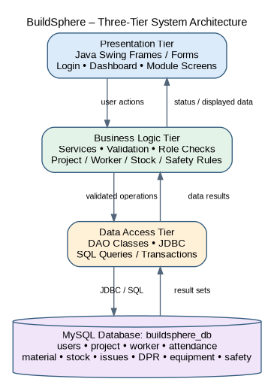
Show Java Swing UI → Business Logic/Services → DAO/JDBC → MySQL Database.

23.1 Architectural Advantages
• Separation of presentation and data access.
• Improved maintainability through modular components.
• Reduced duplication of database access code.
• Clearer testing boundaries.
• Ease of future migration to web or REST services.

24. UML AND MODELING DOCUMENTATION

Use Case Diagram
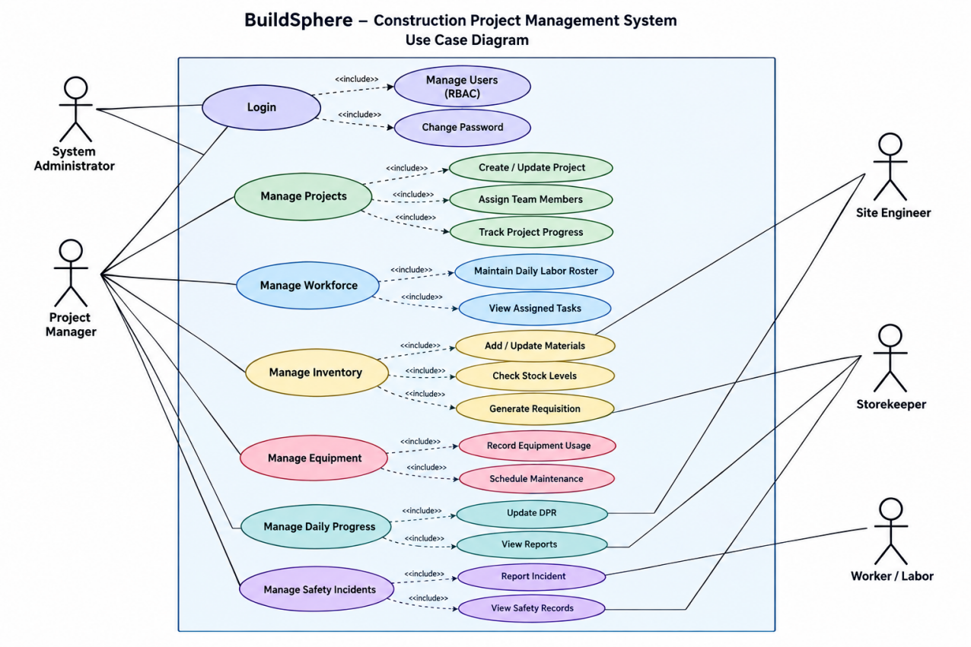
Show actors and their major interactions.

Class Diagram
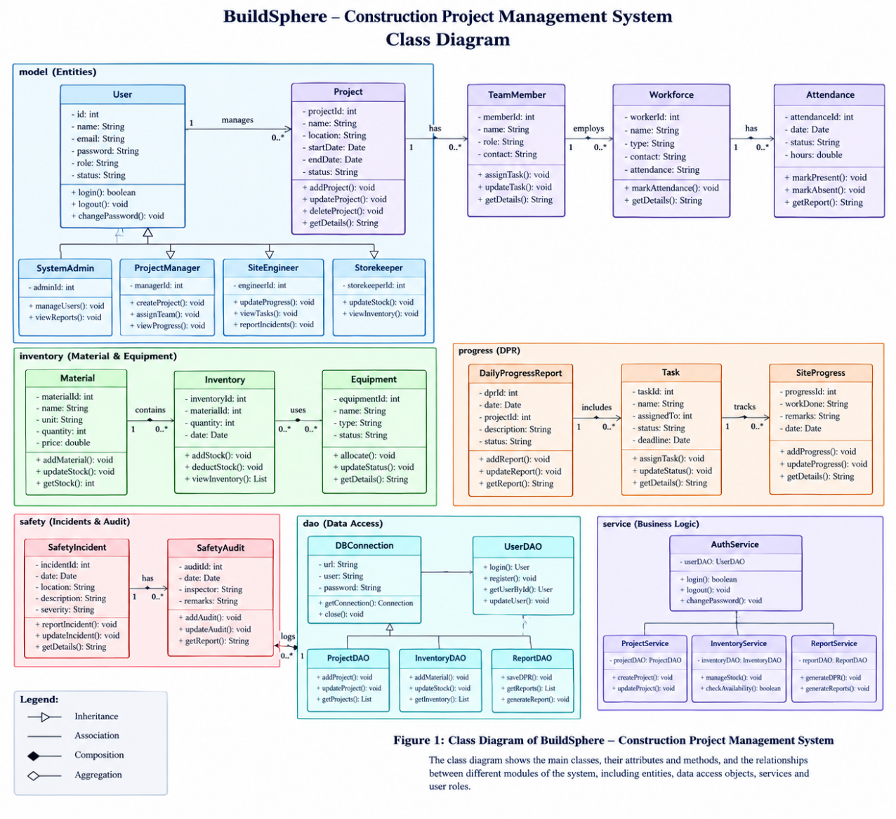
Show domain classes, attributes, methods and relationships.

ER Diagram
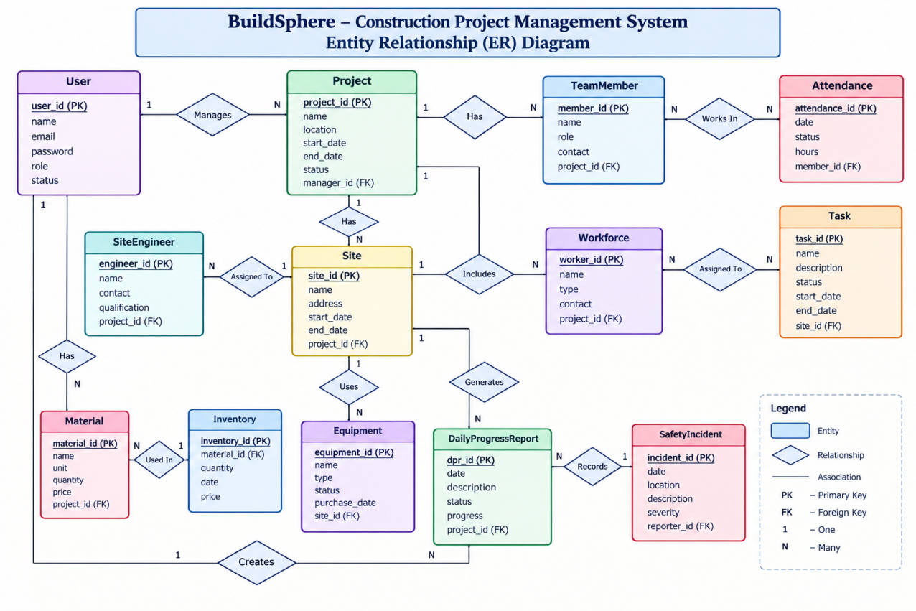
Show the ten principal database entities and relationships.

DFD Level 0
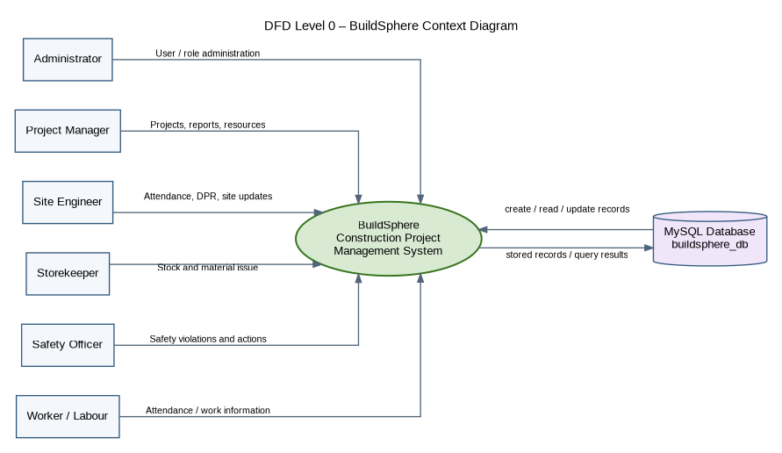
Show BuildSphere as a central process with external users and database.

DFD Level 1
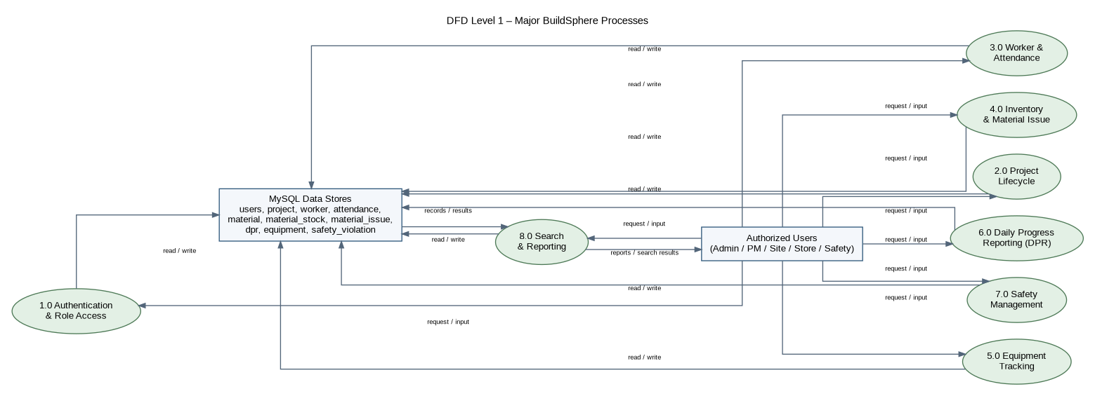
Show authentication, project, labor, inventory, equipment, DPR, safety and reporting processes.

Activity Diagram
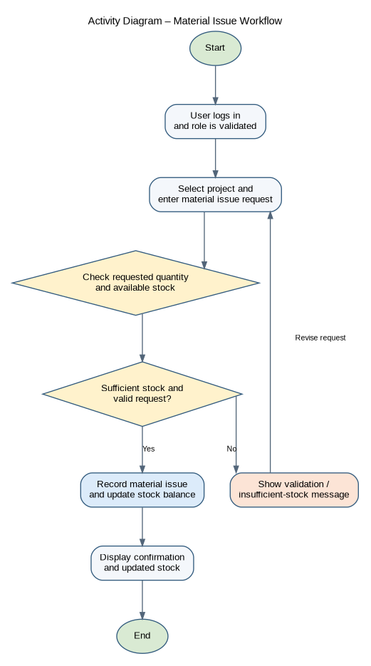
Show attendance and material issue workflows.

Sequence Diagram
Show login and material issue interactions.

Deployment Diagram
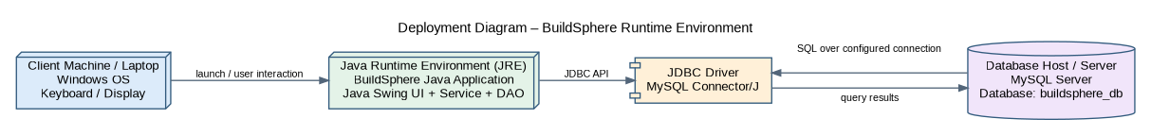
Show client, Java application, JDBC and MySQL server.

25. DATABASE DESIGN AND DATA DICTIONARY
The database named buildsphere_db contains the principal entities required to support project operations. Primary keys uniquely identify records and foreign keys maintain relationships between related entities.
Table | Purpose | Primary Key
users | Application users and roles | user_id
project | Construction project information | project_id
worker | Worker and trade information | worker_id
attendance | Daily attendance | attendance_id
material | Material master | material_id
material_stock | Inward transactions | stock_id
material_issue | Issue transactions | issue_id
dpr | Daily progress | dpr_id
equipment | Equipment records | equipment_id
safety_violation | Safety records | violation_id

25.1 Sample Data Dictionary
Entity | Important Attributes | Purpose
users | username, password, role, full_name | User identity and role
project | project_name, location, dates, status | Project lifecycle
worker | worker_code, name, trade, daily_wage | Worker records
attendance | worker_id, project_id, date, status | Attendance history
material | material_name, unit, min_stock_level | Material catalog
material_stock | material_id, quantity, date | Stock inward
material_issue | material_id, issued_to, quantity | Stock issue
dpr | date, work_done, manpower_used | Daily reporting
equipment | name, type, operator, status | Machinery tracking
safety_violation | category, severity, status | Safety tracking

26. DATABASE NORMALIZATION CASE STUDY

26.1 First Normal Form
In 1NF, each field contains an atomic value and repeating or multi-valued groups are separated into individual records.

26.2 Second Normal Form
In 2NF, non-key attributes depend on the complete primary key. Separating attendance, material and project-specific entities prevents partial dependencies.

26.3 Third Normal Form
In 3NF, non-key attributes depend only on the primary key. Worker details remain in the worker entity rather than being repeatedly stored in attendance records.

26.4 Integrity Constraints
• Primary keys provide unique identification.
• Foreign keys maintain valid relationships.
• UNIQUE constraints prevent duplicates.
• NOT NULL protects mandatory fields.
• Application validation restricts invalid values.
• Transactions protect multi-step inventory updates.

27. IMPLEMENTATION DETAILS

27.1 Application Development
The application uses Java and Java Swing. GUI components such as JFrame, JPanel, JButton and JTable provide the desktop interface.

27.2 JDBC Connectivity
JDBC provides communication between the Java application and MySQL. Prepared statements should be used for parameter handling.

27.3 CRUD Operations
Major master modules follow Create, Read, Update and Delete behavior according to permissions and business rules.

27.4 Validation and Exception Handling
Validation is required for dates, numeric quantities, mandatory fields, duplicate attendance and inventory quantities.

27.5 Transaction Handling
Material issue operations require coordinated updates. A transaction-based approach keeps the issue record and stock update consistent.

28. USER INTERFACE DOCUMENTATION

Login Interface
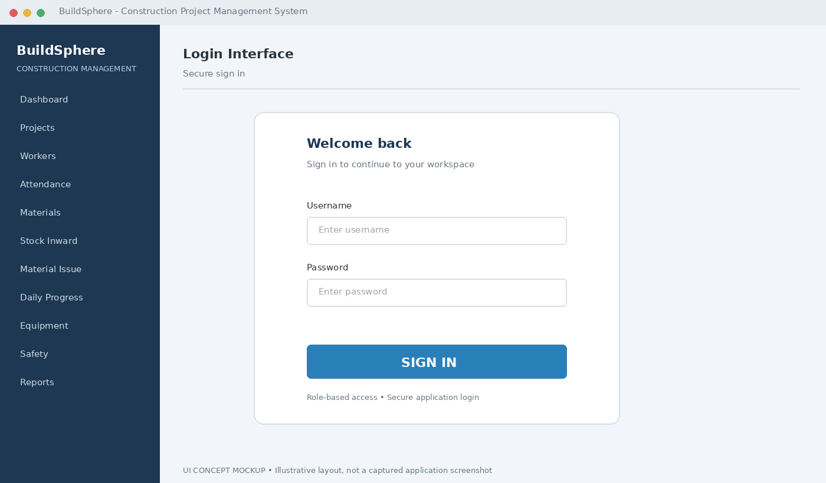
Insert the actual BuildSphere screenshot here and add a 3–5 line explanation of the screen.

Dashboard
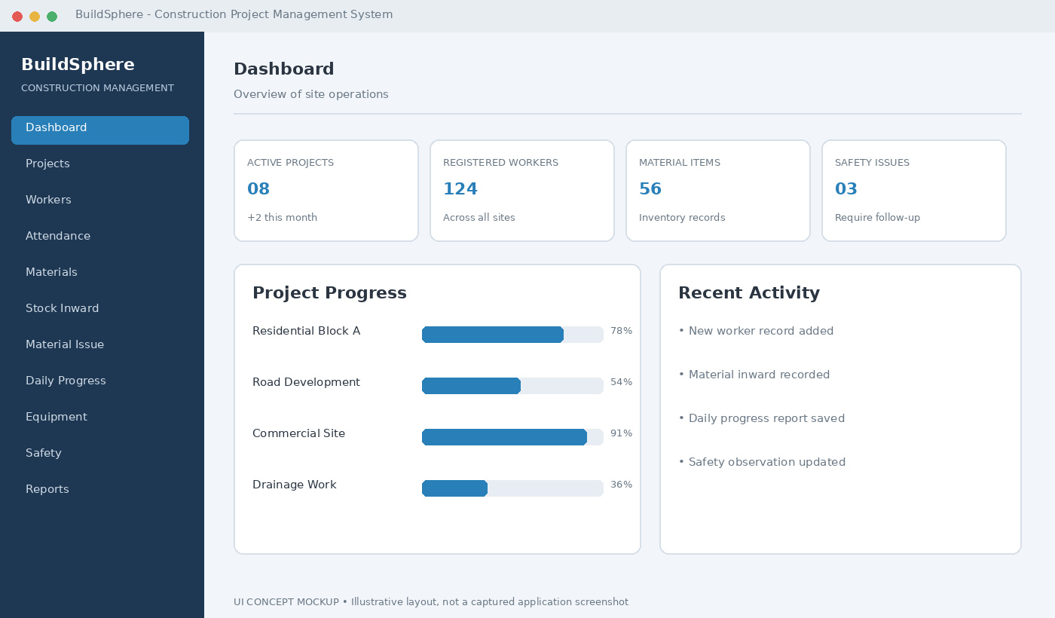
Insert the actual BuildSphere screenshot here and add a 3–5 line explanation of the screen.

Project Management
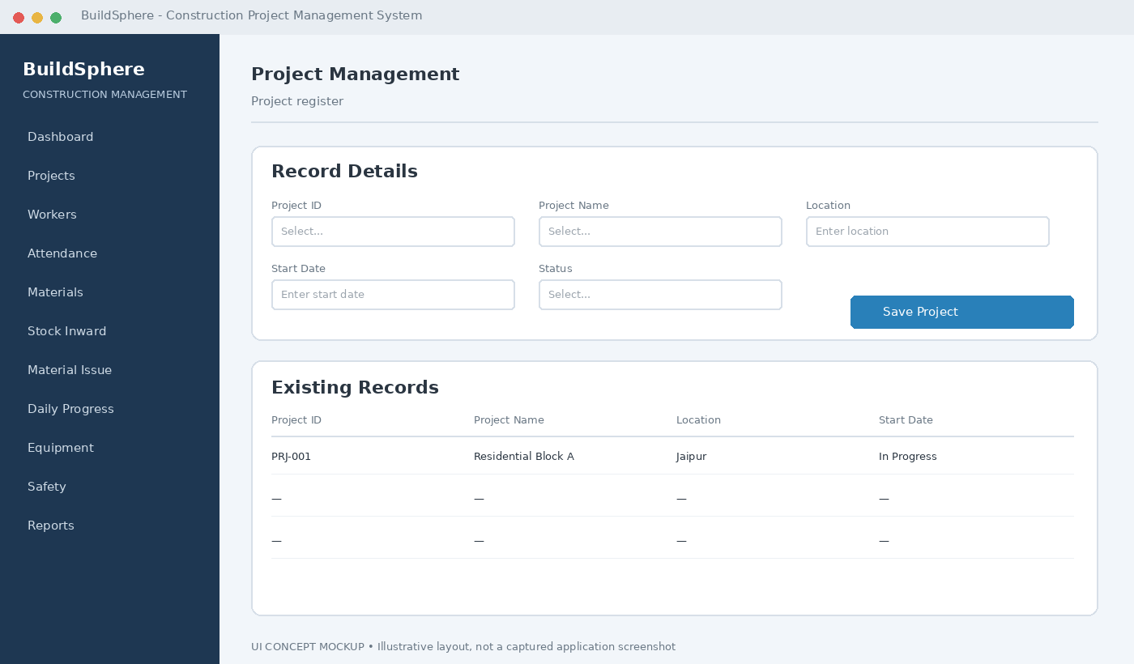
Insert the actual BuildSphere screenshot here and add a 3–5 line explanation of the screen.

Worker Management
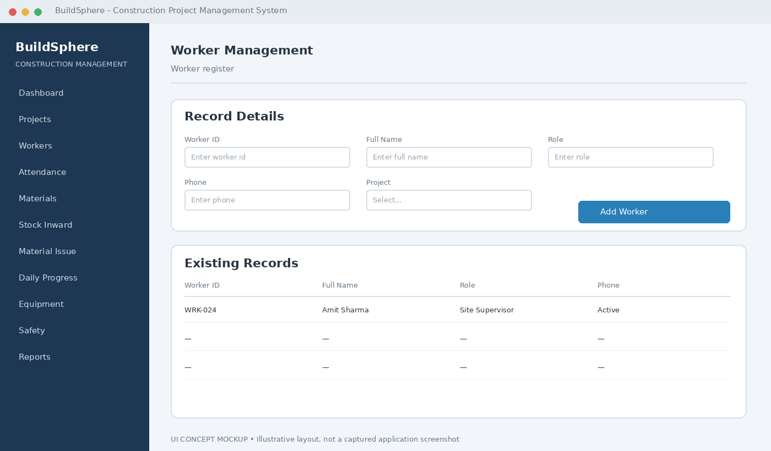
Insert the actual BuildSphere screenshot here and add a 3–5 line explanation of the screen.

Attendance
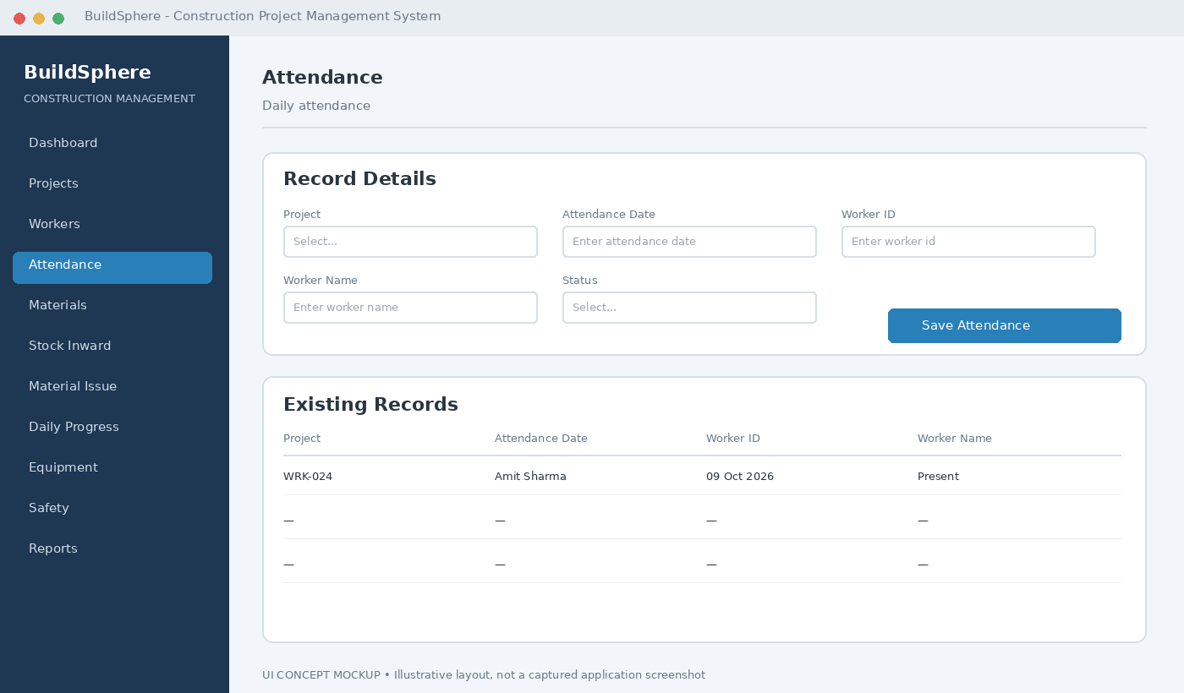
Insert the actual BuildSphere screenshot here and add a 3–5 line explanation of the screen.

Material Management
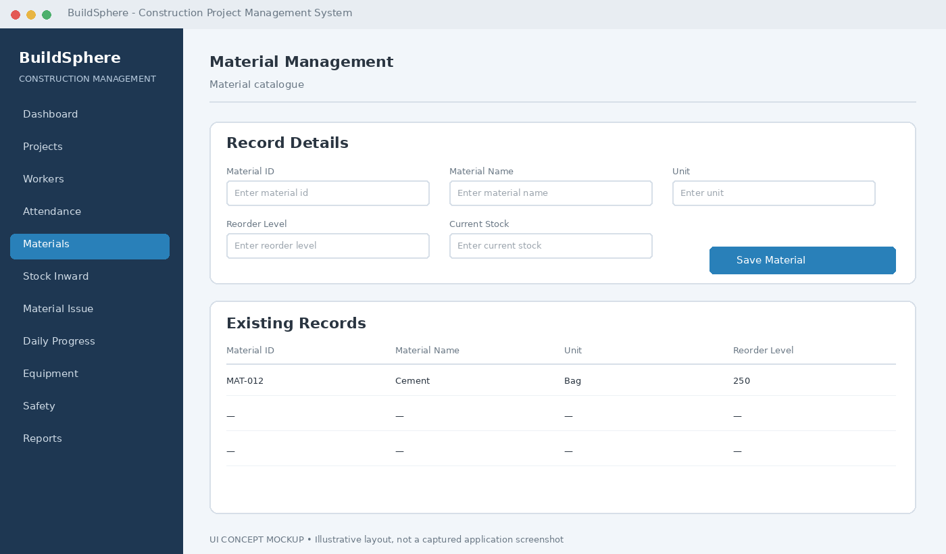
Insert the actual BuildSphere screenshot here and add a 3–5 line explanation of the screen.

Stock Inward
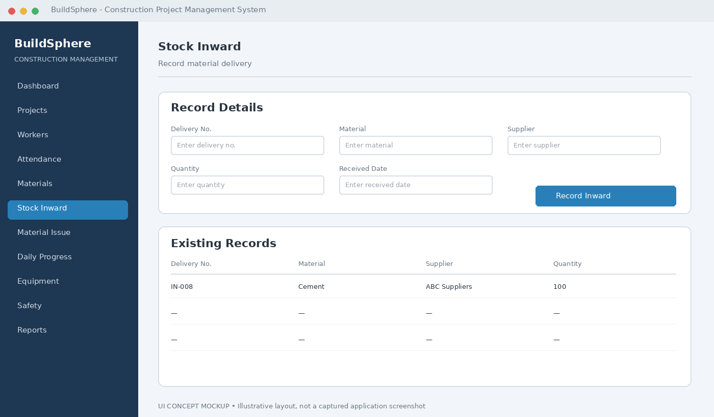
Insert the actual BuildSphere screenshot here and add a 3–5 line explanation of the screen.

Material Issue
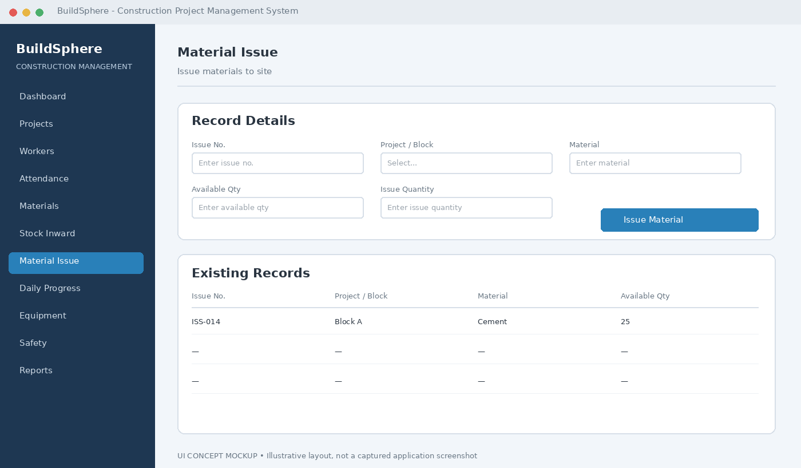
Insert the actual BuildSphere screenshot here and add a 3–5 line explanation of the screen.

Daily Progress Report
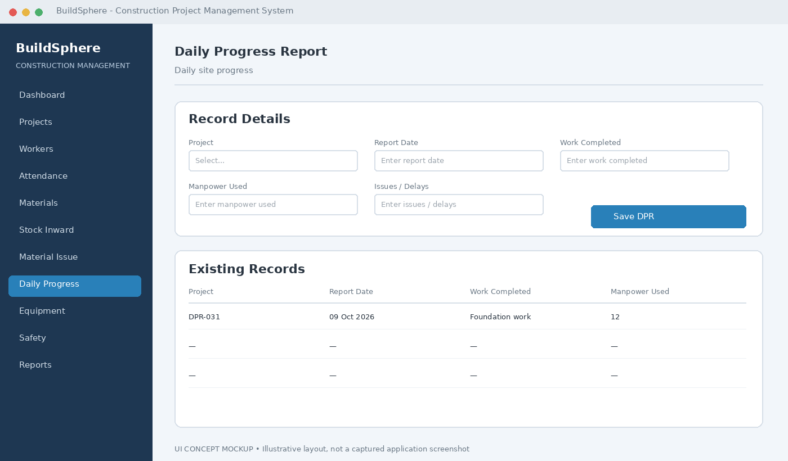
Insert the actual BuildSphere screenshot here and add a 3–5 line explanation of the screen.

Equipment Tracking
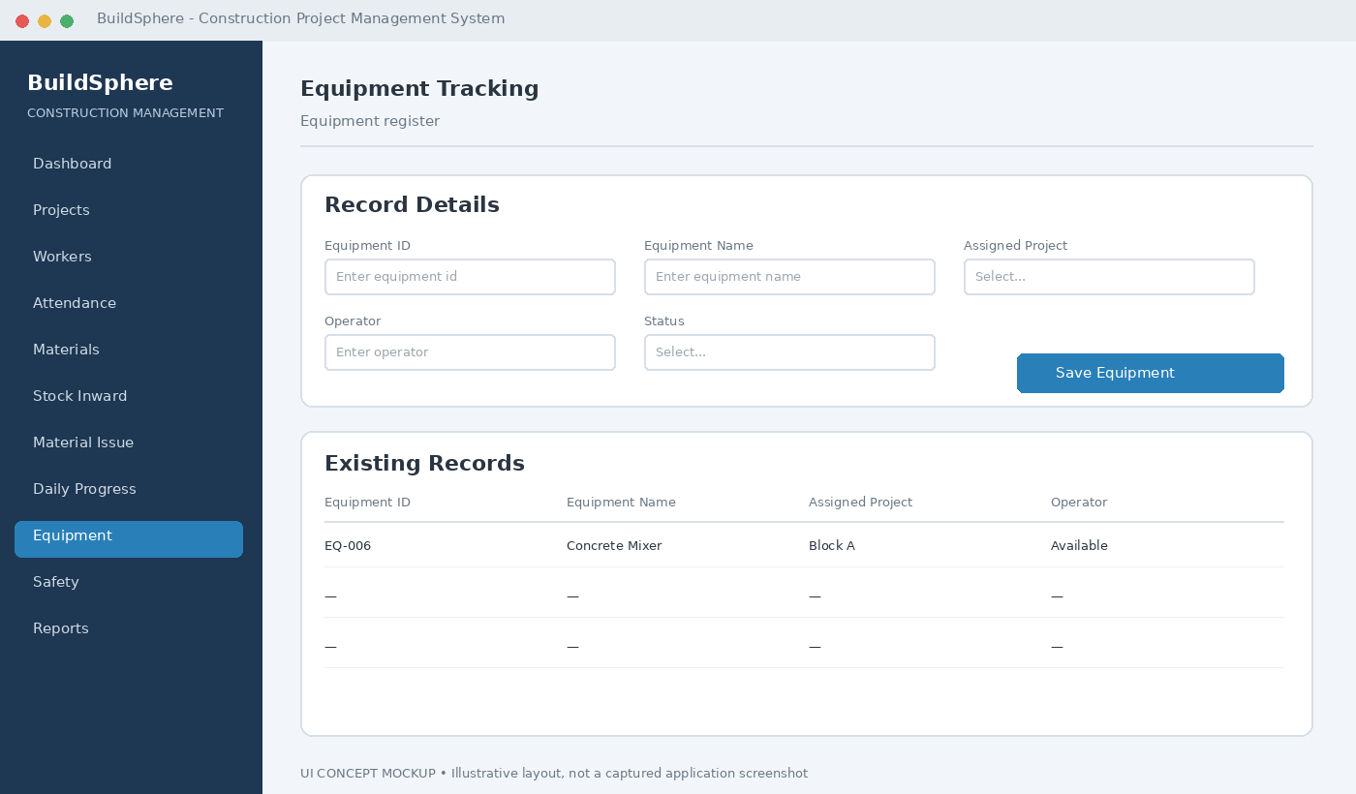
Insert the actual BuildSphere screenshot here and add a 3–5 line explanation of the screen.

Safety Management
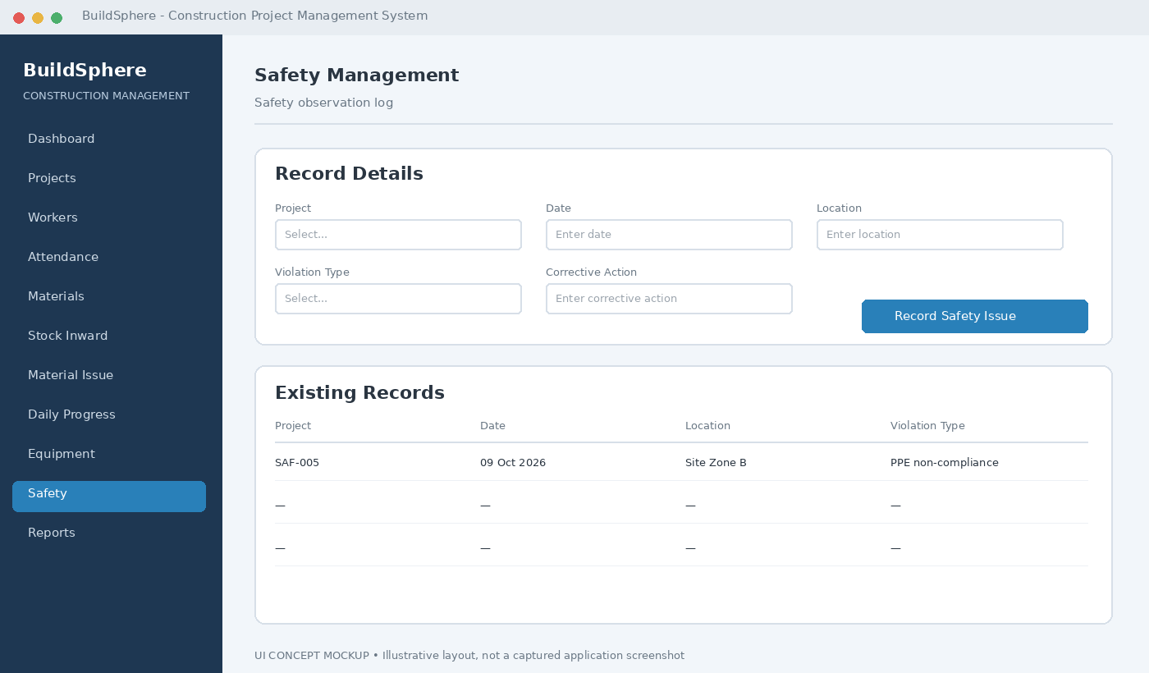
Insert the actual BuildSphere screenshot here and add a 3–5 line explanation of the screen.

Reporting and Search
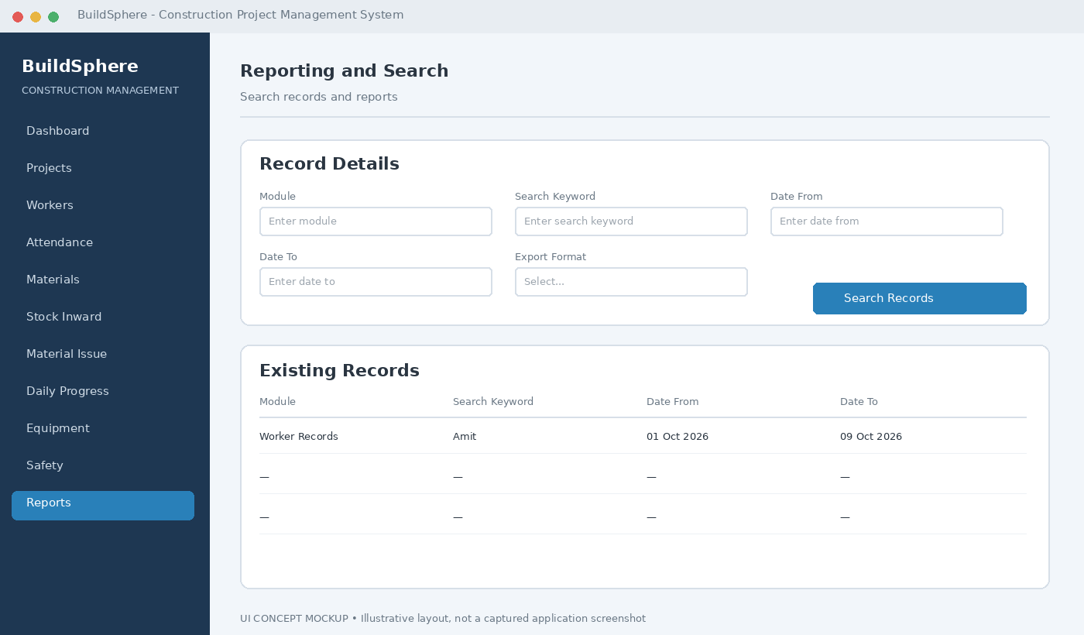
Insert the actual BuildSphere screenshot here and add a 3–5 line explanation of the screen.

29. SOFTWARE TESTING AND VALIDATION
Testing verifies that BuildSphere modules behave according to functional requirements and that invalid operations are handled safely. Testing should include valid, invalid, boundary and duplicate inputs.
ID | Module | Scenario | Expected Result | Status
TC-01 | Login | Valid credentials | Authorized dashboard | Pass
TC-02 | Login | Invalid credentials | Access denied | Pass
TC-03 | Project | Add valid project | Record stored | Pass
TC-04 | Worker | Add valid worker | Record stored | Pass
TC-05 | Attendance | Duplicate daily entry | Rejected | Pass
TC-06 | Material | Add material | Master updated | Pass
TC-07 | Stock | Add inward quantity | Transaction stored | Pass
TC-08 | Material Issue | Issue valid quantity | Balance updated | Pass
TC-09 | Material Issue | Excess quantity | Rejected | Pass
TC-10 | DPR | Submit valid DPR | Record stored | Pass
TC-11 | Equipment | Update status | Status updated | Pass
TC-12 | Safety | Record violation | Saved with severity | Pass

29.1 Testing Types
• Unit Testing
• Integration Testing
• Functional Testing
• Database Testing
• UI Testing
• Validation Testing
• Security-Oriented Testing
• Regression Testing
TESTING EVIDENCE
Insert screenshots of successful test execution, validation messages, database records and outputs.

30. RISK ANALYSIS AND MITIGATION
Risk | Impact | Probability | Mitigation
Database connection failure | High | Medium | Validate settings and handle exceptions.
Invalid input | Medium | High | Form validation.
Duplicate records | Medium | Medium | Unique constraints and duplicate checks.
Incorrect stock update | High | Medium | Validation and transactions.
Database loss | High | Low | Regular backups.
Unauthorized access | High | Medium | Role-based access.
Schedule delay | Medium | Medium | Sprint tracking.

31. PROJECT MANAGEMENT AND TEAM CONTRIBUTION

31.1 Team Responsibilities
Team Member | Suggested Responsibility Area
Rohit Sharma | Core Java / database / module implementation
Shreya Goswami | Documentation / GUI / testing / integration
Somya Vijay | UML / database analysis / testing / presentation

The responsibility allocation should be adjusted before final submission if the actual contribution differs.

31.2 Weekly Progress Record
Week | Activity | Deliverable | Status
1 | Problem identification and requirements | Problem statement | Completed
2 | SRS and analysis | SRS | Completed
3 | UML and architecture | Design diagrams | Completed
4 | Database design | Schema | Completed
5 | Authentication/master modules | Login/project/worker | In Progress
6 | Attendance/inventory | Attendance/material | Scheduled
7 | DPR/equipment/safety | Site modules | Scheduled
8 | Testing/documentation | Final report/demo | Scheduled

32. LIMITATIONS
• Desktop-oriented design.
• Local/intranet database approach.
• No mobile field application in current scope.
• No biometric/IoT attendance in current scope.
• No AI-based prediction in current scope.
• Report quality depends on correct data entry.

33. FUTURE ENHANCEMENT ROADMAP
• Spring Boot REST API.
• Android/Flutter mobile client.
• Cloud database synchronization.
• Biometric and RFID attendance.
• AI-assisted delay and cost prediction.
• BIM integration.
• Drone/computer-vision progress verification.
• Advanced dashboards and analytics.
• Automated low-stock and safety notifications.

34. INSTALLATION AND USER GUIDE

34.1 Prerequisites
• Compatible JDK
• MySQL Community Server
• MySQL Workbench
• Java development environment
• BuildSphere project files

34.2 Installation Procedure
1. Install JDK.
2. Install/configure MySQL Server.
3. Create buildsphere_db using SQL script.
4. Configure database credentials.
5. Open project in IDE.
6. Configure JDBC driver.
7. Run application.
8. Log in using configured account.

34.3 Basic User Workflow
Login → Select authorized module → Enter/search records → Validate → Save transaction → Review result → Generate/inspect reports.

35. CONCLUSION
BuildSphere provides a structured academic implementation of a Construction Project Management System using Java, Java Swing, JDBC and MySQL. It is designed around project management, worker records, attendance, inventory, equipment, daily progress and safety management.
The documented design applies requirement specification, feasibility analysis, modular architecture, UML modeling, relational normalization, role-based access, validation, transaction handling and systematic testing.
The future roadmap provides a path toward mobile access, cloud synchronization, IoT-assisted attendance, predictive analytics and advanced site monitoring.

36. APPENDIX A – SQL AND SOURCE CODE REFERENCE
The original report contains the core MySQL DDL scripts for users, project, worker, attendance, material, material_stock, material_issue, dpr, equipment and safety_violation. Retain these scripts as the database implementation reference.
[ INSERT IMPORTANT JAVA SOURCE CODE HERE ]
Insert selected source-code listings/screenshots for Login, DatabaseConnection, DAO classes, Project, Worker, Inventory and DPR modules.

37. APPENDIX B – FINAL DEMONSTRATION CHECKLIST
Item | Evidence | Done
Login | Valid/invalid login | ☐
Project | CRUD demonstration | ☐
Worker | Registration/search | ☐
Attendance | Entry/duplicate validation | ☐
Material | Master/stock | ☐
Material Issue | Valid/invalid issue | ☐
DPR | Daily progress | ☐
Equipment | Status update | ☐
Safety | Violation entry | ☐
Database | Tables/relationships | ☐
Testing | Test evidence | ☐
Report | Final documentation | ☐

38. REFERENCES
1. IEEE Computer Society, IEEE Std 830-1998: Recommended Practice for Software Requirements Specifications, IEEE, 1998.
2. Ian Sommerville, Software Engineering, 10th Edition, Pearson Education, 2015.
3. Roger S. Pressman and Bruce R. Maxim, Software Engineering: A Practitioner's Approach, 9th Edition, McGraw-Hill Education, 2020.
4. Herbert Schildt, Java: The Complete Reference, 12th Edition, Oracle Press / McGraw-Hill, 2021.
5. MySQL AB, MySQL 8.0 Reference Manual, Oracle Corporation, 2024.
6. Bureau of Indian Standards, National Building Code of India (NBC 2016), Volume 1 & 2, New Delhi, India.
7. Ministry of Labour and Employment, Building and Other Construction Workers (Regulation of Employment and Conditions of Service) Act, 1996, Government of India.
8. Bureau of Indian Standards, IS 456:2000 – Plain and Reinforced Concrete – Code of Practice, Fourth Revision, BIS, New Delhi.

DETAILED SYSTEM ARCHITECTURE
BuildSphere is organized as a modular application in which presentation, application logic and database operations have distinct responsibilities. The interface collects user input and displays results. Application logic validates information and coordinates operations. JDBC provides the connection to the MySQL database. This structure supports maintainability and makes individual modules easier to test.
Layer | Responsibility | Example
Presentation | User interaction | Forms and tables
Business | Validation and rules | Module logic
Data | Persistence | JDBC + MySQL

Figure – System Architecture
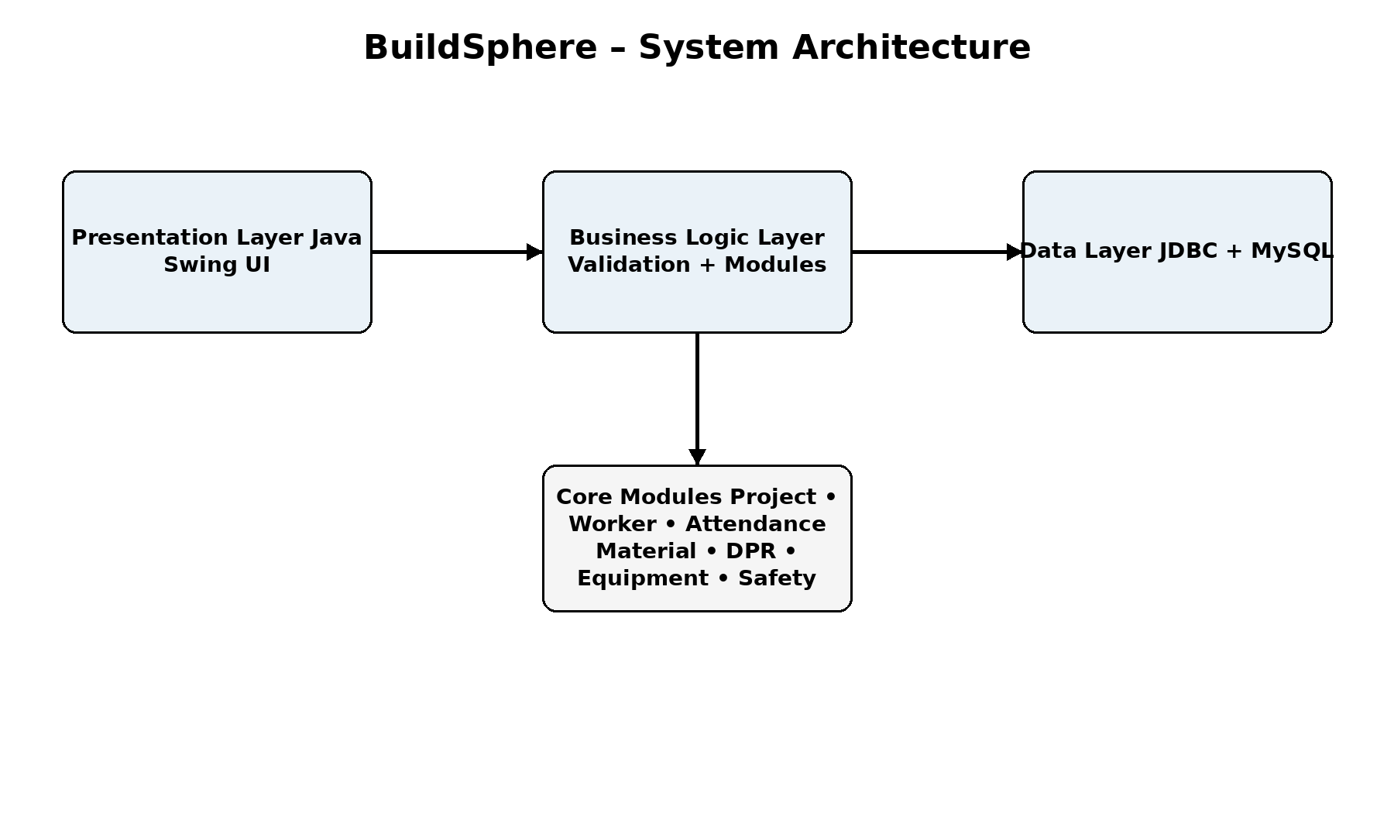
Use the actual final project evidence. Do not use fabricated screenshots.

MODULE-WISE FUNCTIONAL DESIGN
The system is divided into authentication, project, worker, attendance, material, stock, material issue, daily progress, equipment and safety modules. Each module has a focused responsibility and shares information through the project database. This modular design reduces complexity and provides a clear structure for future enhancement.
Module | Purpose
Authentication | Login/access
Project | Project records
Worker | Worker records
Attendance | Daily attendance
Material | Material master
Stock/Issue | Inventory movement
DPR | Daily progress
Equipment | Equipment records
Safety | Safety records

USE CASE MODEL AND ACTORS
The main actors are administrators and operational users such as project managers, site engineers, storekeepers and safety officers. The exact access rights should match the implemented project. The use-case model should show which actor performs authentication, project management, workforce management, inventory operations, progress reporting, equipment tracking and safety operations.
Figure – Actual UML / Flow Diagram
Use the actual final project evidence. Do not use fabricated screenshots.

CLASS AND OBJECT MODEL
The class model should represent the actual Java classes and major domain entities used by BuildSphere. Relationships should be consistent with the implemented database and application flow. The diagram is useful for explaining how object-oriented programming is used to organize the application.
Figure – Actual UML / Flow Diagram
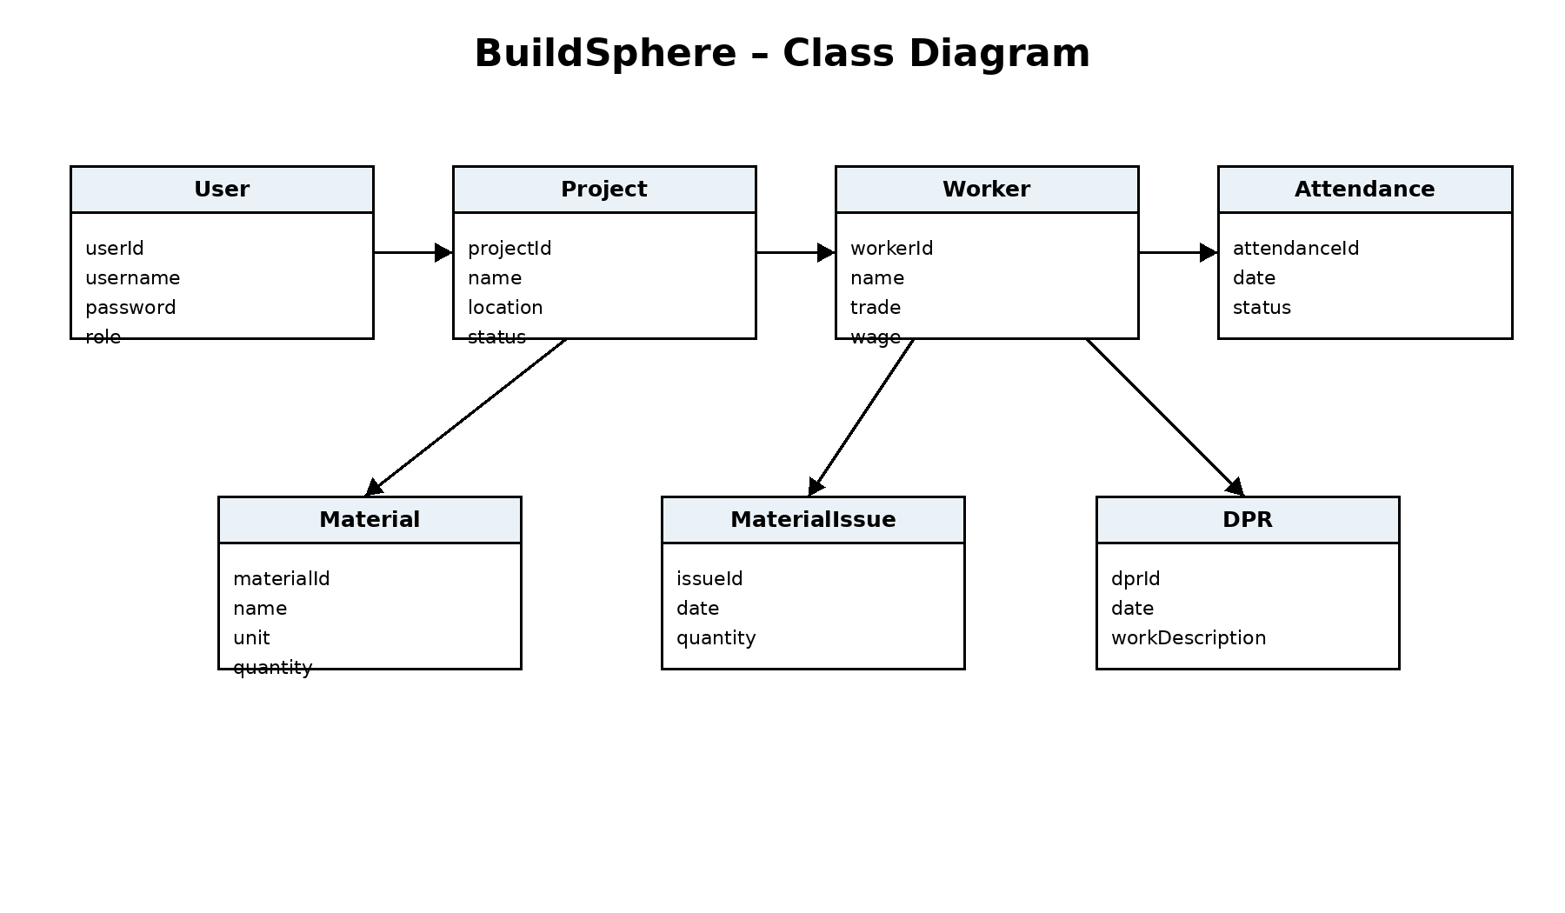

ACTIVITY FLOW – USER LOGIN
The login workflow starts when a user enters credentials. Required fields are validated first. The credentials are then checked against the stored user information. If valid, the application opens the authorized area; otherwise, a clear validation message is displayed. The workflow should avoid exposing technical database information to normal users.
Figure – Actual UML / Flow Diagram
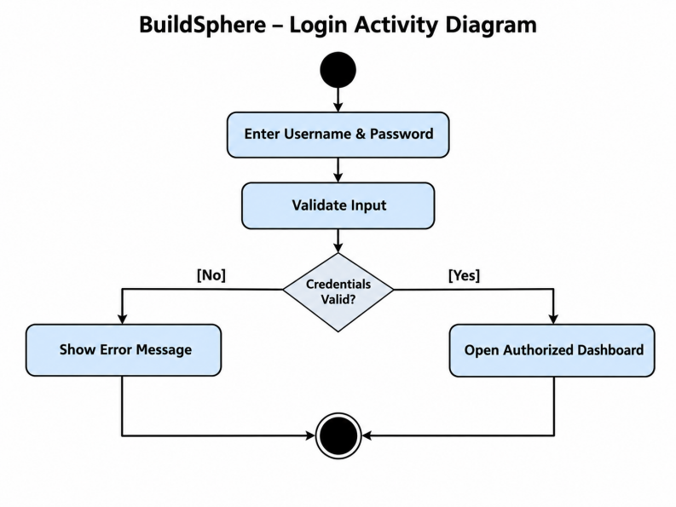

SEQUENCE FLOW – MATERIAL ISSUE
A material issue begins with selecting a material and entering the quantity. The application validates the input and checks available stock according to the implemented logic. A valid transaction is recorded and the relevant stock information is updated. Invalid quantities are rejected with an understandable message.
Figure – Actual UML / Flow Diagram
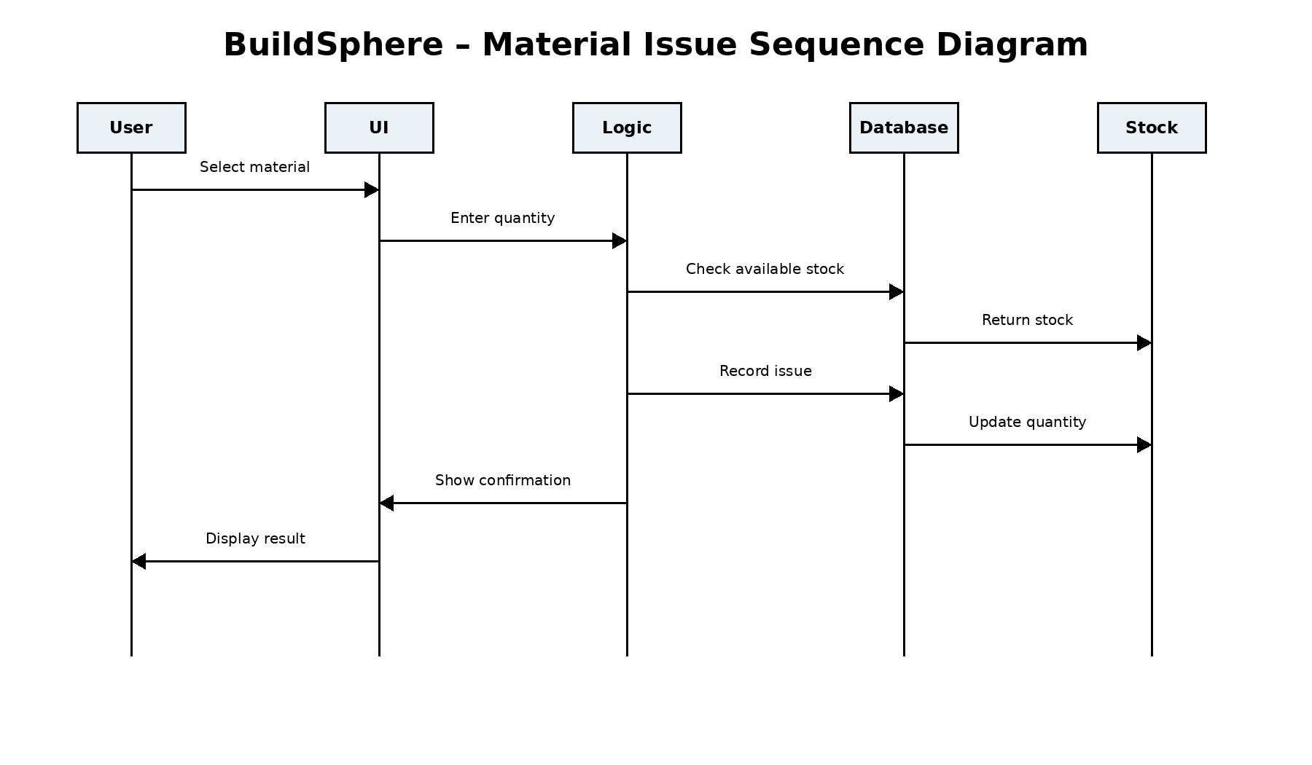

ENTITY RELATIONSHIP DESIGN
The database includes related entities for users, projects, workers, attendance, materials, stock, material issues, daily progress, equipment and safety violations. Primary keys uniquely identify records and foreign keys connect dependent records. The final ER diagram must correspond to the actual SQL schema used by the project.
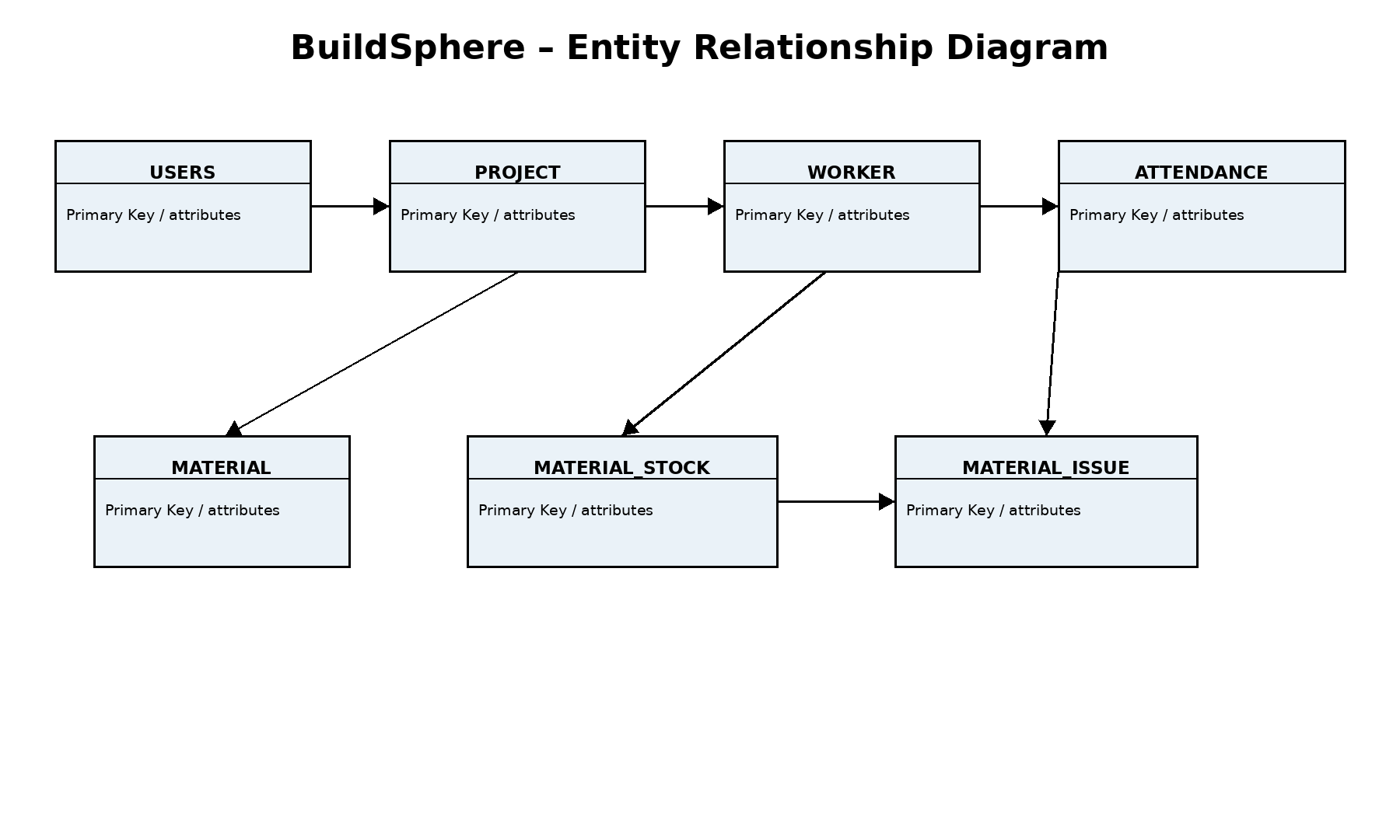

DATABASE TABLE SUMMARY
The database is named buildsphere_db. Its documented tables include users, project, worker, attendance, material, material_stock, material_issue, dpr, equipment and safety_violation. Each table has a specific responsibility so that operational information remains structured and traceable.
Table | Purpose
users | Users and roles
project | Project information
worker | Worker information
attendance | Attendance records
material | Material master
material_stock | Stock records
material_issue | Issue records
dpr | Daily progress
equipment | Equipment records
safety_violation | Safety records

DATA VALIDATION AND INTEGRITY
Validation should occur before database operations. Required fields should not be blank, quantities should contain valid values, and related records should refer to existing parent records. Database constraints and application-level checks should work together to reduce inconsistent information.
Validation | Expected Behavior
Required field | Reject blank input
Numeric quantity | Reject invalid value
Duplicate record | Prevent/flag duplicate
Foreign key | Require valid related record

USER INTERFACE DESIGN
A professional interface should use consistent labels, spacing, buttons, tables and navigation. Forms should clearly identify their purpose, while validation messages should explain what the user needs to correct. Actual screenshots from the final BuildSphere application should be used as evidence.

LOGIN AND DASHBOARD DOCUMENTATION
The login screen establishes access to the application, while the dashboard provides navigation to available modules. Documentation should explain the fields, buttons and navigation flow. The final report should contain an actual screenshot captured from the running application.
Figure – Actual BuildSphere Screenshot
[INSERT ACTUAL BUILDSPHERE PROJECT SCREENSHOT / DIAGRAM HERE]
Use the actual final project evidence. Do not use fabricated screenshots.
Evidence | Purpose
UI screenshot | Show implemented screen
Database record | Show saved data
Validation | Show correct response

PROJECT, WORKER AND ATTENDANCE
Project records provide the context for site operations. Worker records identify personnel, while attendance connects a worker with a date and attendance status. These modules form the basic workforce-management portion of BuildSphere and should be demonstrated with actual application screenshots.
Figure – Actual BuildSphere Screenshot
[INSERT ACTUAL BUILDSPHERE PROJECT SCREENSHOT / DIAGRAM HERE]
Use the actual final project evidence. Do not use fabricated screenshots.
Evidence | Purpose
UI screenshot | Show implemented screen
Database record | Show saved data
Validation | Show correct response

MATERIAL AND INVENTORY
Material management separates material master information from movement information. Stock records document incoming or available quantities, while issue records document material usage. This approach supports traceability and makes inventory information easier to review.
Figure – Actual BuildSphere Screenshot
[INSERT ACTUAL BUILDSPHERE PROJECT SCREENSHOT / DIAGRAM HERE]
Use the actual final project evidence. Do not use fabricated screenshots.
Evidence | Purpose
UI screenshot | Show implemented screen
Database record | Show saved data
Validation | Show correct response

DPR, EQUIPMENT AND SAFETY
Daily Progress Reports document work performed at the site. Equipment records provide information about machinery or equipment and its status. Safety violation records document safety-related observations. Together these modules extend BuildSphere into operational site management.
Figure – Actual BuildSphere Screenshot
[INSERT ACTUAL BUILDSPHERE PROJECT SCREENSHOT / DIAGRAM HERE]
Use the actual final project evidence. Do not use fabricated screenshots.
Evidence | Purpose
UI screenshot | Show implemented screen
Database record | Show saved data
Validation | Show correct response

TESTING MATRIX
Testing should cover successful operations, invalid inputs, duplicate records, database interactions and boundary conditions. Every final test case should be executed on the actual build before being marked Pass. Screenshots may be attached as evidence for important cases.
ID | Test | Expected | Result
T01 | Valid login | Dashboard opens | Fill after execution
T02 | Invalid login | Access denied | Fill after execution
T03 | Add project | Saved | Fill after execution
T04 | Add material | Saved | Fill after execution
T05 | Invalid quantity | Rejected | Fill after execution

DEFECT MANAGEMENT AND RETESTING
A defect record should include the module, problem, severity, expected behavior, actual behavior, correction and retest result. After correction, the original test should be executed again. This demonstrates that development changes were verified rather than assumed to be correct.
Defect | Severity | Correction | Retest
Invalid input accepted | Medium | Add validation | Required
Duplicate entry | Medium | Constraint/check | Required

SECURITY, BACKUP AND MAINTENANCE
Security considerations include protecting database credentials, limiting access according to implemented roles and safely handling database operations. Backups should be taken before major schema changes. Modular code and reusable database components make maintenance easier.
• Do not expose database passwords in screenshots.
• Use safe parameterized database operations for user input.
• Maintain backups before major database changes.
• Restrict functions according to implemented roles.
• Handle exceptions with understandable messages.

PROJECT SCHEDULE AND TEAM CONTRIBUTION
The project schedule can be organized into requirements, design, database development, implementation, integration, testing and documentation. Team contribution should describe only work actually performed by each member. Weekly progress should contain dates, activities and evidence.
Phase | Activity | Evidence
1 | Requirements | SRS
2 | Design | UML
3 | Database | SQL/schema
4 | Implementation | Screenshots
5 | Testing | Test cases
6 | Documentation | Final report

RESULTS, LIMITATIONS AND FUTURE SCOPE
The result chapter should summarize only functionality that was actually implemented and tested. Limitations should be stated honestly. Future scope may include web or mobile access, cloud deployment, notifications, analytics, IoT integration and advanced reporting if these features are not part of the current build.
Area | Documentation
Implemented modules | List actual modules
Database | Attach final schema
Testing | Attach executed results
Limitations | State actual boundaries
Future scope | Separate proposed features

DATA FLOW DIAGRAM
The Level 0 data flow diagram shows the movement of requests from the user through the BuildSphere application to the MySQL database and the return of results.
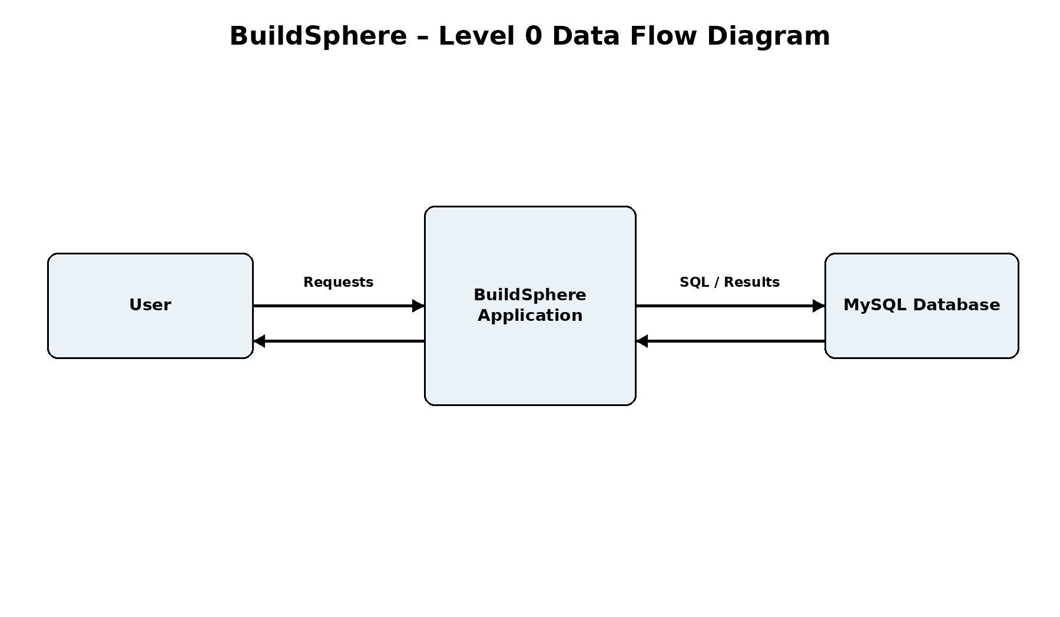

DEPLOYMENT DIAGRAM
The deployment view represents the client application, Java/JDBC application layer and MySQL database environment used for the project.
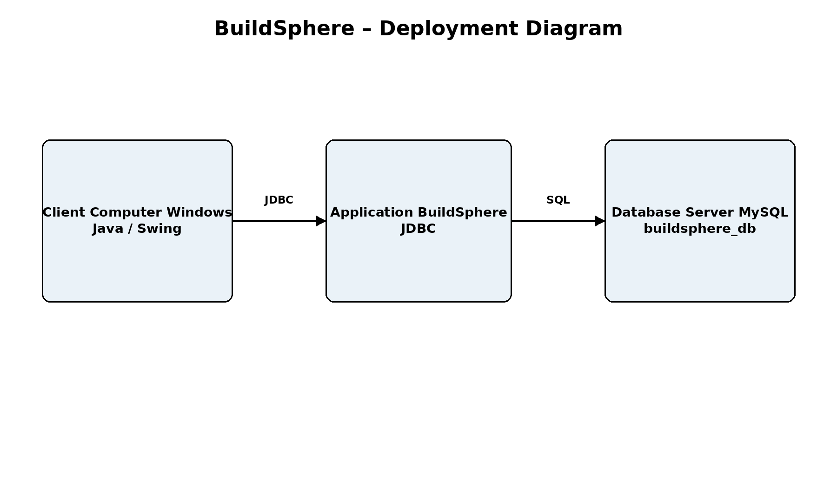THANK YOU

